

Database Systems

Department of Computer Engineering

Spring 2021

Final Report

Online Course Platform - Sapientia

Project Group 4:

* Ömer Ünlüsoy - Section 01 - 21702136
* Elif Gamze Güliter - Section 01 - 21802870
* İrem Tekin - Section 01 - 21803267
* Ece Ünal - Section 01 - 21703149

Supervisor:

* Uğur Güdükbay

Table of Contents

1. Introduction 4

1.1 Contribution of Each Group Member 4

2. Final E/R Diagram 5

3. Final Relation Schemas 6

3.1. Student 6

3.2. Instructor 6

3.3. Admin 6

3.4. Course 6

3.5. Section 6

3.6. Lecture 6

3.7. Quiz 7

3.8. Quiz_Question 7

3.9. Note 7

3.10. Course_Announcement 7

3.11. QnA_Entry_Student 8

3.12. QnA_Entry_Instructor 8

3.13. Complaint_Entry_Student 8

3.14. Complaint_Entry_Instructor 8

3.15. Wishlist 8

3.16. Enrolls 9

3.17. Certificate 9

3.18. Teaches 9

3.19. Evaluates_Complaint_Entry_Student 9

3.20. Evaluates_Complaint_Entry_Instructor 9

3.21. Discount 10

3.22. Zoom_Session 10

3.23. Take_Quiz 10

3.24. Take_Quiz_Question 10

3.25. Take_Lecture 10

4. Implementation Details 11

4.1. Languages 11

4.2. Database and Connection 11

4.3. Implementation 11

5. Advance Database Features 12

5.1. Student Main Page Course Query 12

5.2. Login Page Course Query 12

5.3. Admin Refund Request Query 13

5.4. Certificate Query 13

5.5. Lecture Content Order Query 13

6. User Manual 14

6.1. Instructor User Manual 14

6.2. Student User Manual 14

6.3. Admin User Manual 14

7. Website 14

8. Appendix 15

8.1. SQL Create Table Code 15

# 1. Introduction

In this project, we implemented a web-based course platform similar to Udemy [1]. The purpose of the platform is to enable instructors to build their online courses as well as students to reach out to these contents and educate themselves. The name of the platform is **Sapientia** which means **wisdom** in Latin. In Sapientia, instructors can create courses about the topics that they are proficient about and students can purchase these courses in order to enroll. A course consists of several sections that have lectures as well as quizzes. Students can watch the lectures and solve quizzes. Students receive a certificate indicating that they have finished the online course if only if they watch all of the lectures and get at least the threshold value that is decided by the instructor as their quiz averages. In addition, Sapientia consists of students’ wishlist, students’ notes for a specific lecture, Q&A section for students and instructors to interact with each other, ratings of courses, discount or refund for courses, and at last, announcements made by instructors about a course.

## Contribution of Each Group Member

#### Ömer Ünlüsoy

Contributed to E/R Diagram design. Designed the relational schemas. Designed the SQL create table queries. Implemented several data manipulation queries including search and filter. Implemented several pages like contents, view lecture, view quiz.

#### İrem Tekin

#### Gamze Güliter

I have worked on Graphical User Interface most of the time, I implemented most of the pages with the help of Irem and Ece. I also helped my friends on back-end side. I assisted them on implementation of php and debugging process.

#### Ece Ünal

# 2. Final E/R Diagram

Note: Used software does not have a dashed underline so weak entities are marked with italic underline for this E/R.

# 3. Final Relation Schemas

## Student

Student(SID, name, e_mail, password, membership_type)

## Instructor

Instructor(IID, name, e_mail, password)

## Admin

Admin(AID, name, e_mail, password, salary)

## Course

Course(CID, IID, course_name, description, rating, category, level, cost, discount_allowed, quiz_threshold)

Foreign Key: IID REFERENCES Instructor(IID)

Unique: (IID, course_name)

## 

## Section

Section(CID, section, title)

Foreign Key: CID REFERENCES Course(CID)

Index: section

## Lecture

Lecture(CID, section, content_num, title, lecture_content, description)

Foreign Key: (CID, section) REFERENCES Section(CID, section)

Unique: (CID, title)

Index: section

Index: content_num

## Quiz

Quiz(CID, section, content_num, IID, section, title)

Foreign Key: (CID, section) REFERENCES Section(CID, section)

Foreign Key: IID REFERENCES Instructor(IID)

Unique: (CID, title)

Index: section

Index: content_num

## Quiz_Question

Quiz_Question(CID, section, content_num, question_num, question_text, choice1, choice2, choice3, answer)

Foreign Key: (CID, section, content_num) REFERENCES Quiz(CID, section, content_num)

## Note

Note(Note_ID, SID, section, content_num, time, text)

Foreign Key: SID REFERENCES Student(SID)

## Course_Announcement

Course_Announcement(Ann_ID, IID, CID, date, subject_name, text)

Foreign Key: IID REFERENCES Instructor(IID)

Foreign Key: CID REFERENCES Course(CID)

## QnA_Entry_Student

QnA_Entry_Student(QnA_ID_S, SID, CID, subject_name, text, date)

Foreign Key: SID REFERENCES Student(SID)

Foreign Key: CID REFERENCES Course(CID)

## QnA_Entry_Instructor

QnA_Entry_Instructor(QnA_ID, QnA_ID_S, IID, CID, subject_name, text, date)

Foreign Key: QnA_ID_SREFERENCES QnA_Entry_Student(QnA_ID_S)

Foreign Key: IID REFERENCES Instructor(IID)

Foreign Key: CID REFERENCES Course(CID)

## Complaint_Entry_Student

Complaint_Entry_Student(Complaint_ID, SID, CID, subject_title, text, date, refund_request)

Foreign Key: SID REFERENCES Student(SID)

Foreign Key: CID REFERENCES Course(CID)

## 

## Complaint_Entry_Instructor

Complaint_Entry_Instructor(Complaint_ID, SID, CID, subject_name, text, date)

Foreign Key: IID REFERENCES Instructor(IID)

Foreign Key: CID REFERENCES Course(CID)

## Wishlist

Wishlist(SID, CID)

Foreign Key: SID REFERENCES Student(SID)

Foreign Key: CID REFERENCES Course(CID)

## Enrolls

Enrolls(SID, CID, progress, date)

Foreign Key: SID REFERENCES Student(SID)

Foreign Key: CID REFERENCES Course(CID)

## Certificate

Certificate(SID, CID, certificate_text, rating, comment, date)

Foreign Key: SID REFERENCES Student(SID)

Foreign Key: CID REFERENCES Course(CID)

## Teaches

Teaches(IID, CID)

Foreign Key: IID REFERENCES Instructor(IID)

Foreign Key: CID REFERENCES Course(CID)

## Evaluates_Complaint_Entry_Student

Evaluates_Complaint_Entry_Student(AID, Complaint_ID, response, isRefund)

Foreign Key: AID REFERENCES Admin(AID)

Foreign Key: IID Complaint_ID REFERENCES Complaint_Entry_Student(Complaint_ID)

## Evaluates_Complaint_Entry_Instructor

Evaluates_Complaint_Entry_Instructor(AID, Complaint_ID, response)

Foreign Key: AID REFERENCES Admin(AID)

Foreign Key: Complaint_ID REFERENCES Complaint_Entry_Instructor(Complaint_ID)

## Discount

Discount(AID, CID, rate)

Foreign Key: AID REFERENCES Admin(AID)

Foreign Key: CID REFERENCES Course(CID)

## Zoom_Session

Zoom_Session(Session_ID, IID, CID, invite_link, start_date)

Foreign Key: IID REFERENCES Instructor(IID)

Foreign Key: CID REFERENCES Course(CID)

## Take_Quiz

Take_Quiz(SID, CID, section, content_num, grade)

Foreign Key: SID REFERENCES Student(SID)

Foreign Key: (CID, section, conent_num) REFERENCES Quiz(CID, section, content_num)

## Take_Quiz_Question

Take_Quiz_Question(SID, CID, section, content_num, question_num, answer, isTrue)

Foreign Key: SID REFERENCES Student(SID)

Foreign Key: (CID, section, content_num, question_num) REFERENCES Quiz(CID, section, content_num, question_num)

## Take_Lecture

Take_Quiz_Lecture(SID, CID, section, content_num, isCompleted)

Foreign Key: SID REFERENCES Student(SID)

Foreign Key: (CID, section, conent_num) REFERENCES Lecture(CID, section, content_num)

# 4. Implementation Details

## 4.1. Languages

Four different languages have been used in this project. The first language is SQL which is used for database definition and modification. The second language is PHP. It is used to send queries to the database at the server side. The connection to the database has been established by PHP. The third language is HTML which is used to create Web user interface. HTML is selected due to its compatibility with PHP. Both PHP and HTML code is located at .php files and they can send information to each other which eases the coding. Last language is CSS, a style sheet language helped project to look pretty. Most HTML and CSS code have been produced by an application called Nicepage. IntelliJ and PHPstorm IDEs are used.

## 4.2. Database and Connection

MySQL has been used in this project for both database definition and modification. The database is located at one member’s Dijkstra account so that every member can access. The connection is established by a PHP script.

## 4.3. Implementation

First, the E/R diagram and schemas are designed as the first stage of the implementation. SQL create table queries are designed and tables are created at a Dijkstra account. Main page structure of the website is determined and SQL database manipulation queries are designed for each page. Then, page user interfaces are implemented with HTML and CSS. At this point, the app created static HTML and CSS codes which was a major challenge for the UI part.

After implementing the UI, HTML files are turned into PHP files and UI components like buttons and text fields, are connected. After then, SQL manipulation queries are implemented in PHP files and each query is tested with several cases. Finally, page and session connections are implemented.

Gamze Güliter and Ece Ünal were mainly responsible from the web UI (HTML and CSS) while Ömer Ünlüsoy and İrem Tekin were mainly responsible for SQL queries and PHP. However, every group member has worked at every stage of the implementation.

# 5. Advance Database Features

## 5.1. Student Main Page Course Query

select *   
from Discount right join Course on Course.CID = Discount.CID and   
rate between $discount_min and $discount_max

natural join Instructor  
where  
cost between $price_min and $price_max

and category = $category and level = $level

and (course_name like %$search_word% or Instructor.name like %$search_word%)  
limit $page_num, $page_entry_num;



Figure 1: Example run with rate between 0, 20; cost between 10, 50; category = Music; level = Beginner; search word = music

This query shows all the courses that satisfy student’s criteria at the student main page. Everything starting with $ sign is a variable taken from the student. This query joins three tables; uses price, level, and discount filters. It also implements search feature with “like” phrase. Finally, it uses “limit” to limit the number of Courses listed at each page.

## 5.2. Login Page Course Query

select *   
from Discount right join Course on Course.CID = Discount.CID

natural join Instructor  
order by rate DESC   
limit 0, 5;

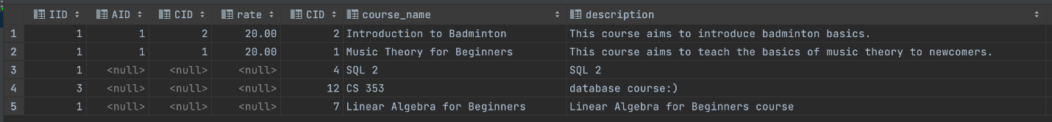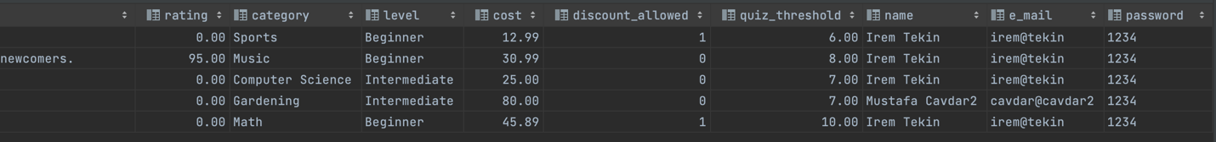

Figure 2: Example run

This query lists top five courses according to their discount rate at the login page.

## 5.3. Admin Refund Request Query

select count(*) as refund_count  
from Complaint_Entry_Student  
where CID = '$CID' and refund_request = 1;

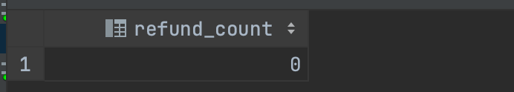

Figure 3: Example run with CID = 3

This query counts the number of refund request made by a specific student for admin.

## 5.4. Certificate Query

select *  
from ( select course_name, CID  
 from Course  
 ) as C_subquery

natural join Certificate   
where SID = '$SID';



Figure 4: Example run with SID = 1

This nested query shows every course, particular student has finished and got certificate for.

## 5.5. Lecture Content Order Query

select *   
from Lecture  
where CID = '$CID' and section = '$section_name'  
order by content_num;



Figure 5: Example run with CID = 1 and section = 1

This query lists every lecture in a particular section of a course and orders according to their content number in the section.

# 6. User Manual

## 6.1. Instructor User Manual

#### 6.1.1. Instructor Log In

Instructors will login to the Sapientia website by the Login Page.

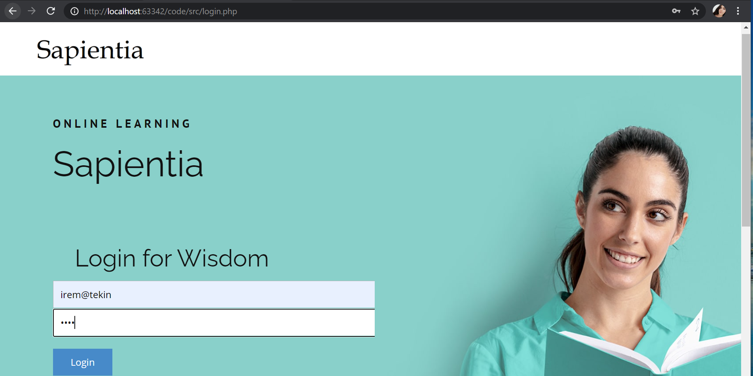

Fig. 6. Instructor Login

#### 6.1.2. Instructor’s Main Page

After log in, instructors will be directed to the main page which lists all the courses that the instructor teaches. In order to see this page, the instructor can also use the **“My Courses**” button in the navigation bar.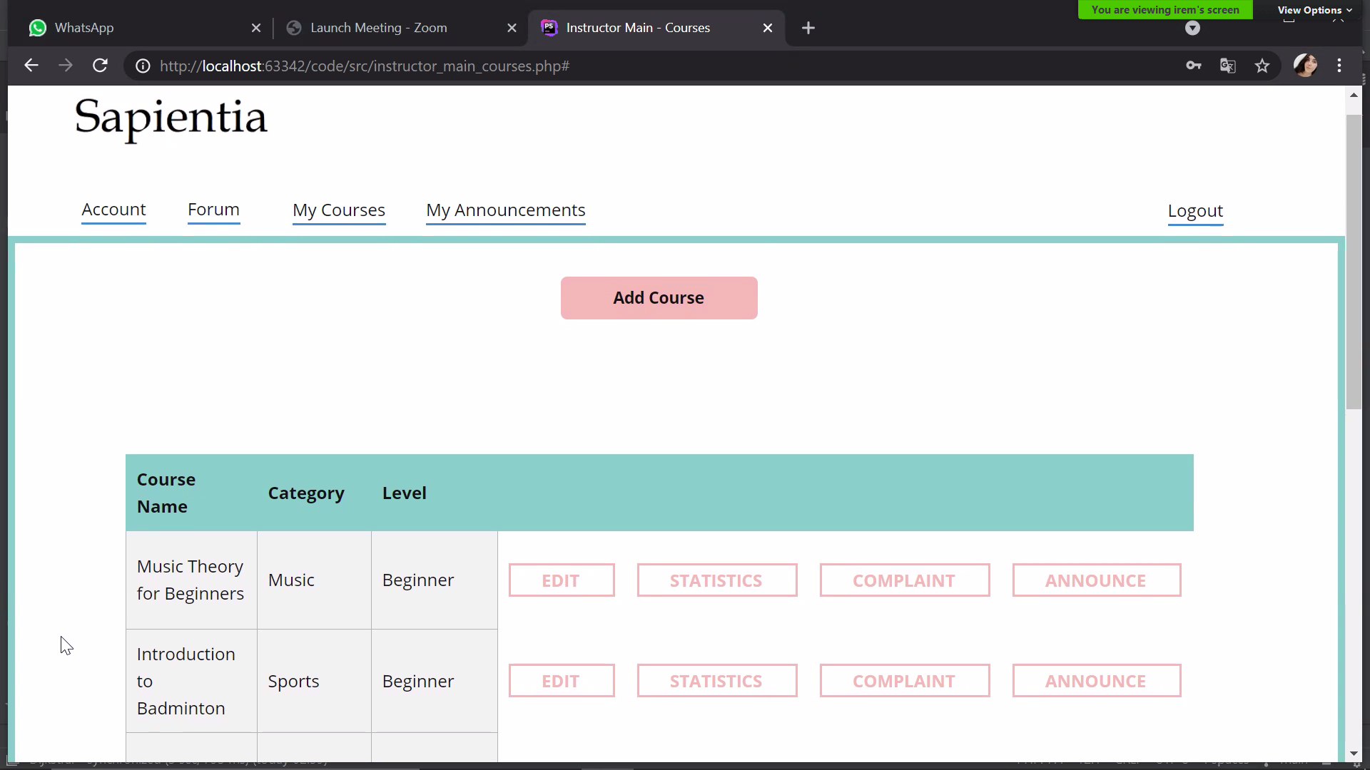Fig. 7. Instructor’s Main Page

#### 6.1.3. Adding a Course to the Sapientia Website

In order to add a course, instructor should press the **“Add a Course”** button on the main page. This button will direct the instructor to the **“Add a Course”** page. In Add a Course page, the instructor should specify the name of the course that he/she will teach, category, the level of course, brief description about the course, its price and quiz threshold. Quiz threshold indicates the min grade that a student needs to collect from the quizzes in order to get a certificate from the course.

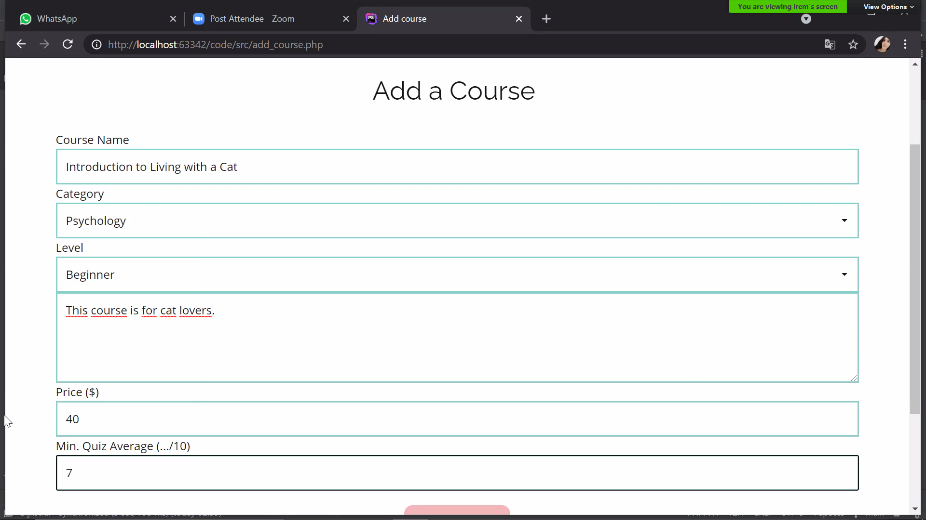

Fig.8. Adding a course to the Sapientia website

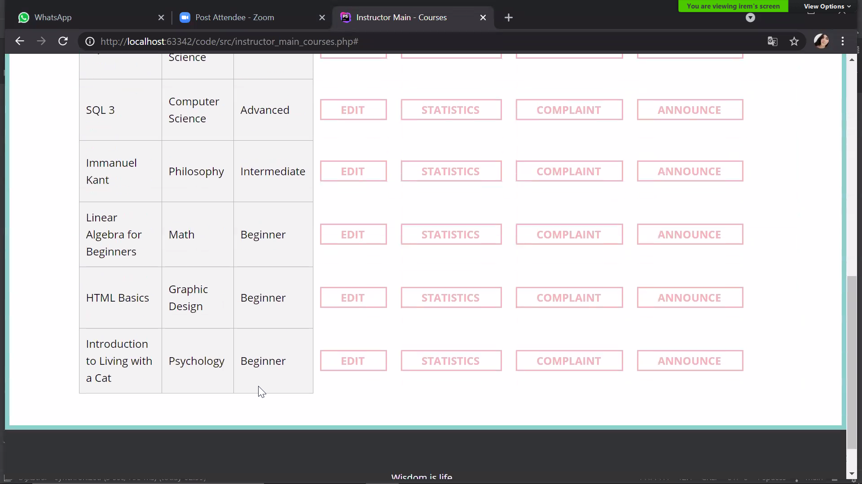

Fig.9. Instructor’s main page after adding a course with the name “Introduction to Living with Cats”

#### 6.1.4. Editing an Added Course

In order to edit a course, the instructor should press the “**Edit**” button next to the course name in the main page. Editing a course includes uploading lecture videos, uploading quizzes, changing its name, price, quiz threshold, level, description etc.

As an **additional feature,** the instructor can schedule a zoom meeting with the enrolled students by giving a date and a zoom link. In order to schedule a zoom meeting, the instructor needs to use **“Edit a Course”** page.

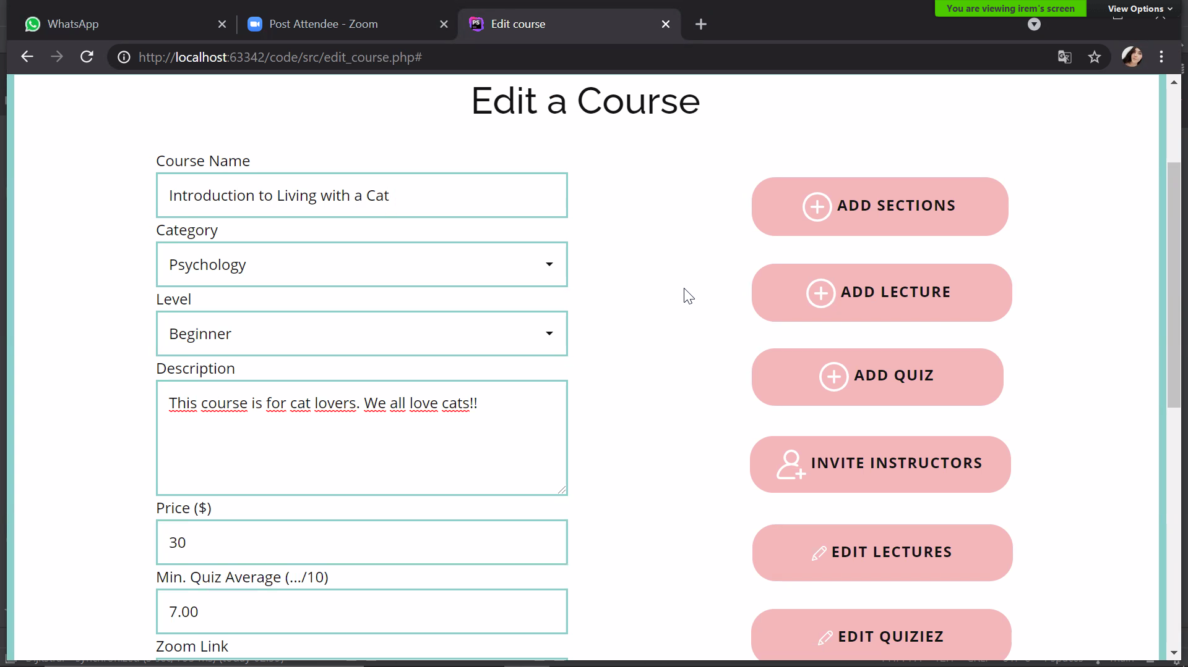

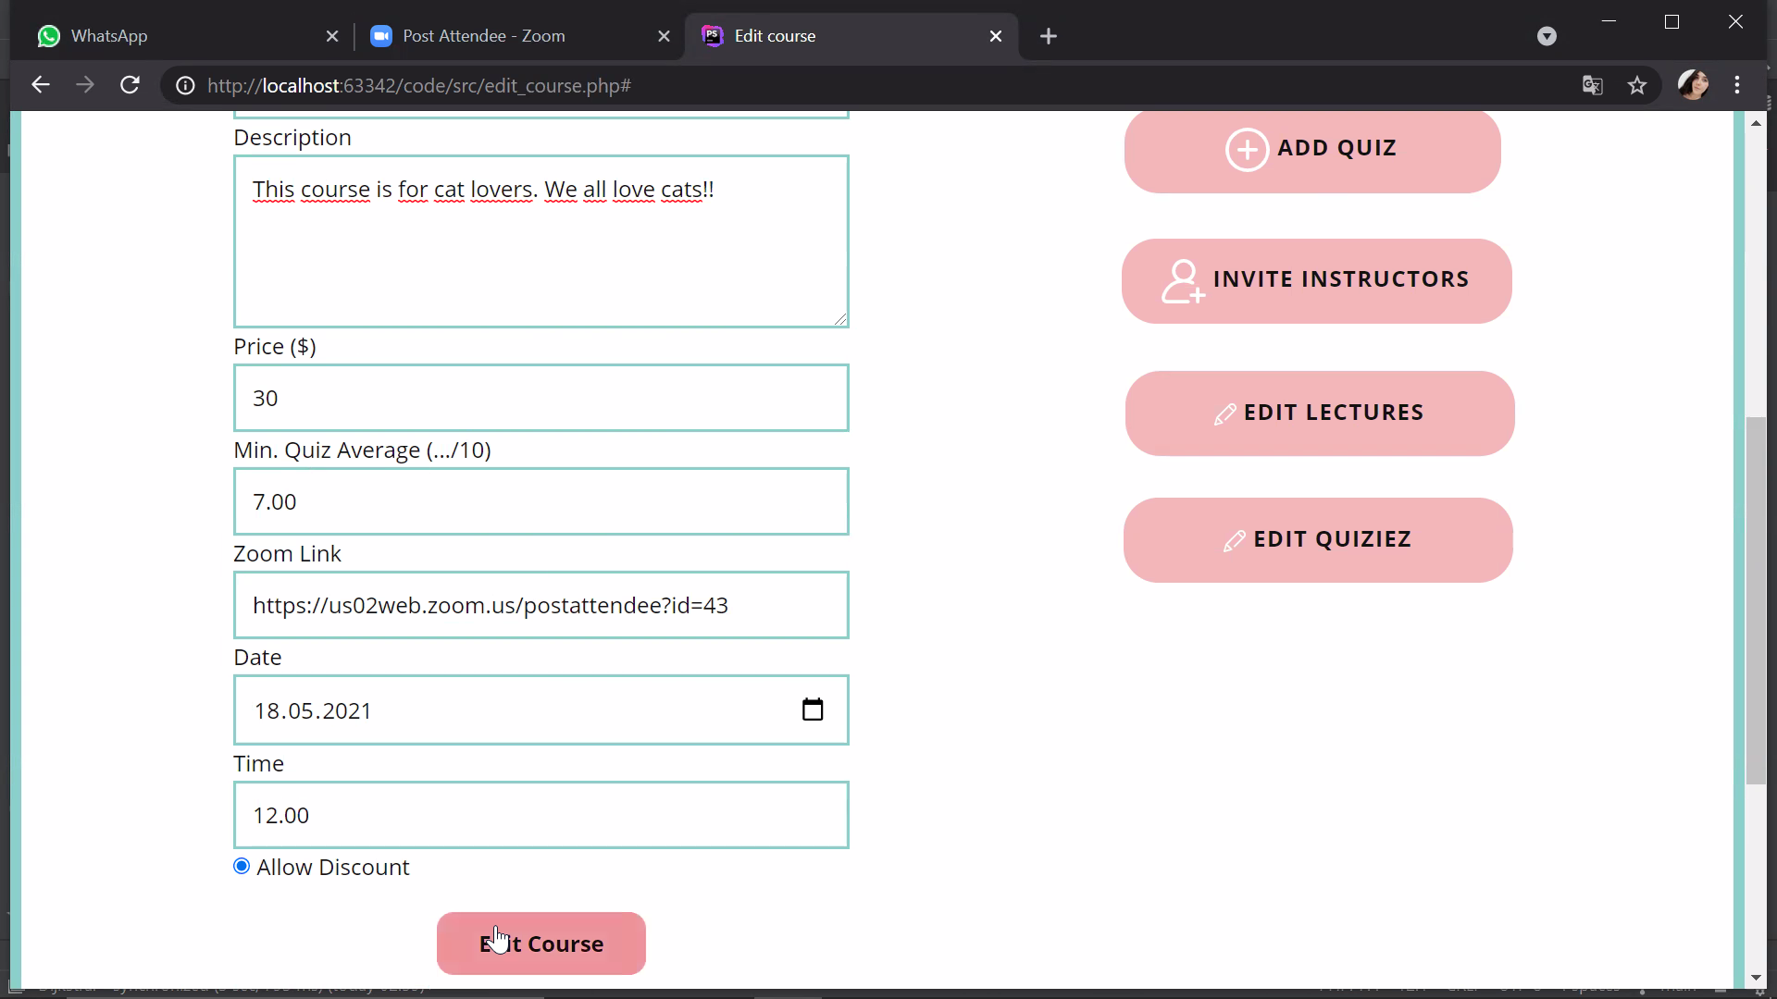

Fig 10 and 11. Edit a Course Page

#### 6.1.5 Adding Sections to a Course

In Sapientia, instructors should add sections to their courses, then, add lectures and quizzes. In order to add a section to the course, the instructor should use the “**Add a Section”** button in the course’s edit page. While adding a section, instructor should specify a name and a number for the section.

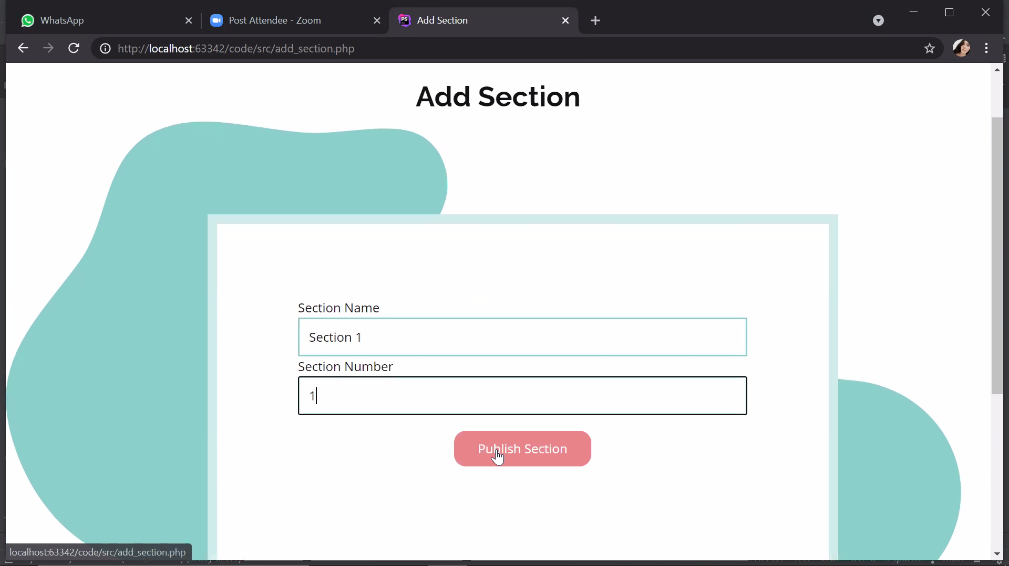

Fig.12 Adding a Section to the Course

#### 6.1.6 Adding Lectures to the Course

In order to add a lecture to the course, an instructor first needs to add at least one section to the course. Following that, in order to add a lecture, the instructor should press the **“Add a Lecture”** button in the edit page. The button will direct the instructor to the “Add a Lecture” page. From that page, the teacher must specify a name, a number, brief description, and a section for the lecture.

In order to upload a lecture video, the instructor must press to the **“Submit Video**” button on the right corner and upload a lecture video from the local computer (See Figures 15,16)

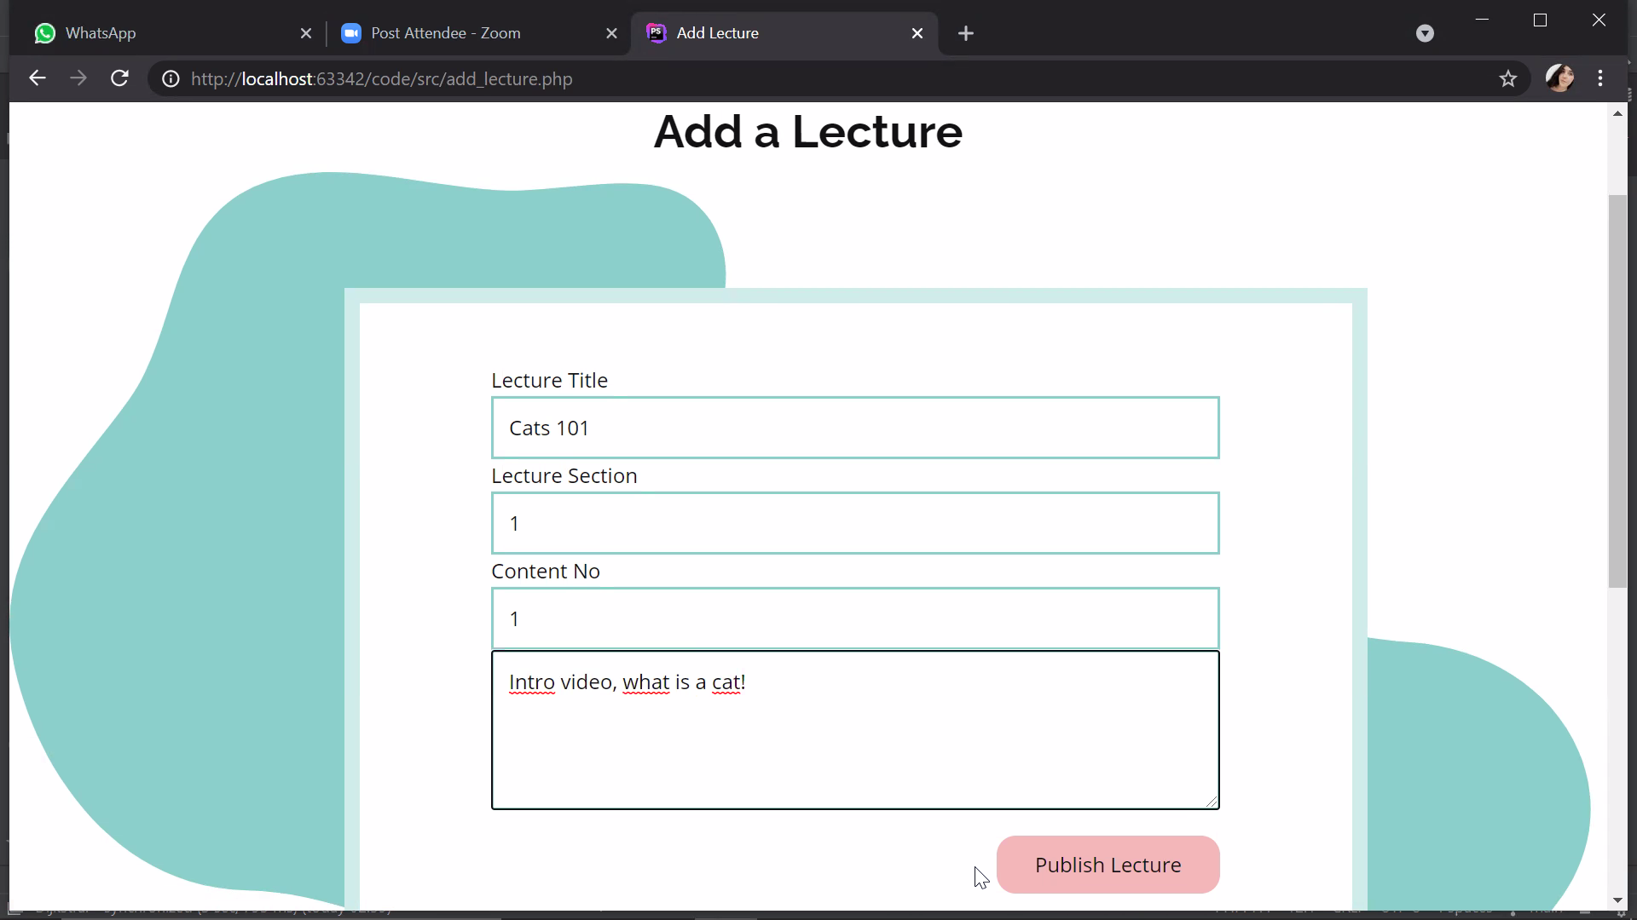

Fig. 13. Add a Lecture Page

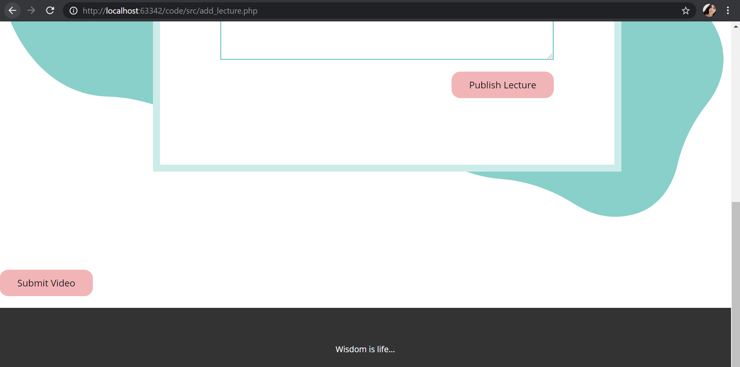

Fig.14 Submit Video Button

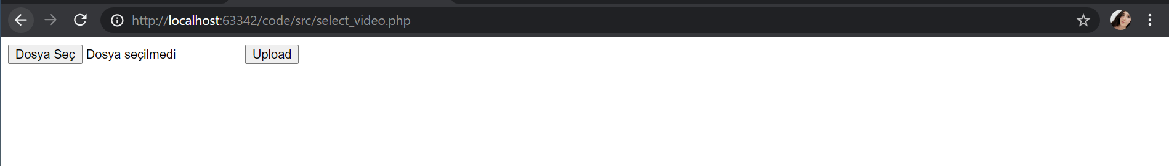

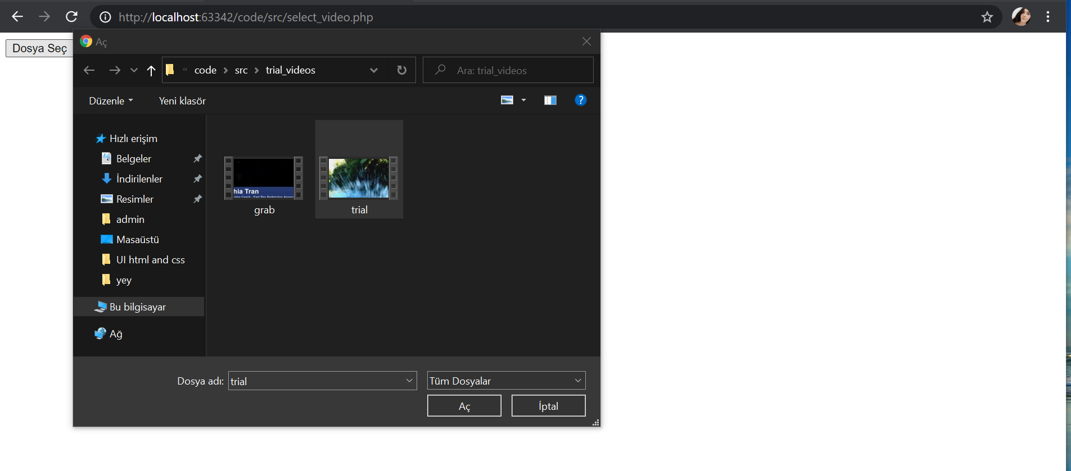

Fig 15 and 16. Uploading a Lecture Video from Local Computer

#### 6.1.7 Adding Quizzes to the Course

In order to add a course to the course, an instructor first needs to add at least one section to the course. Following that, in order to add a quiz, the instructor should press the **“Add a Quiz”** button in the edit page. The button will direct the instructor to the “Add a Quiz” page. From that page, the teacher must specify a name, a number and a section for the quiz.

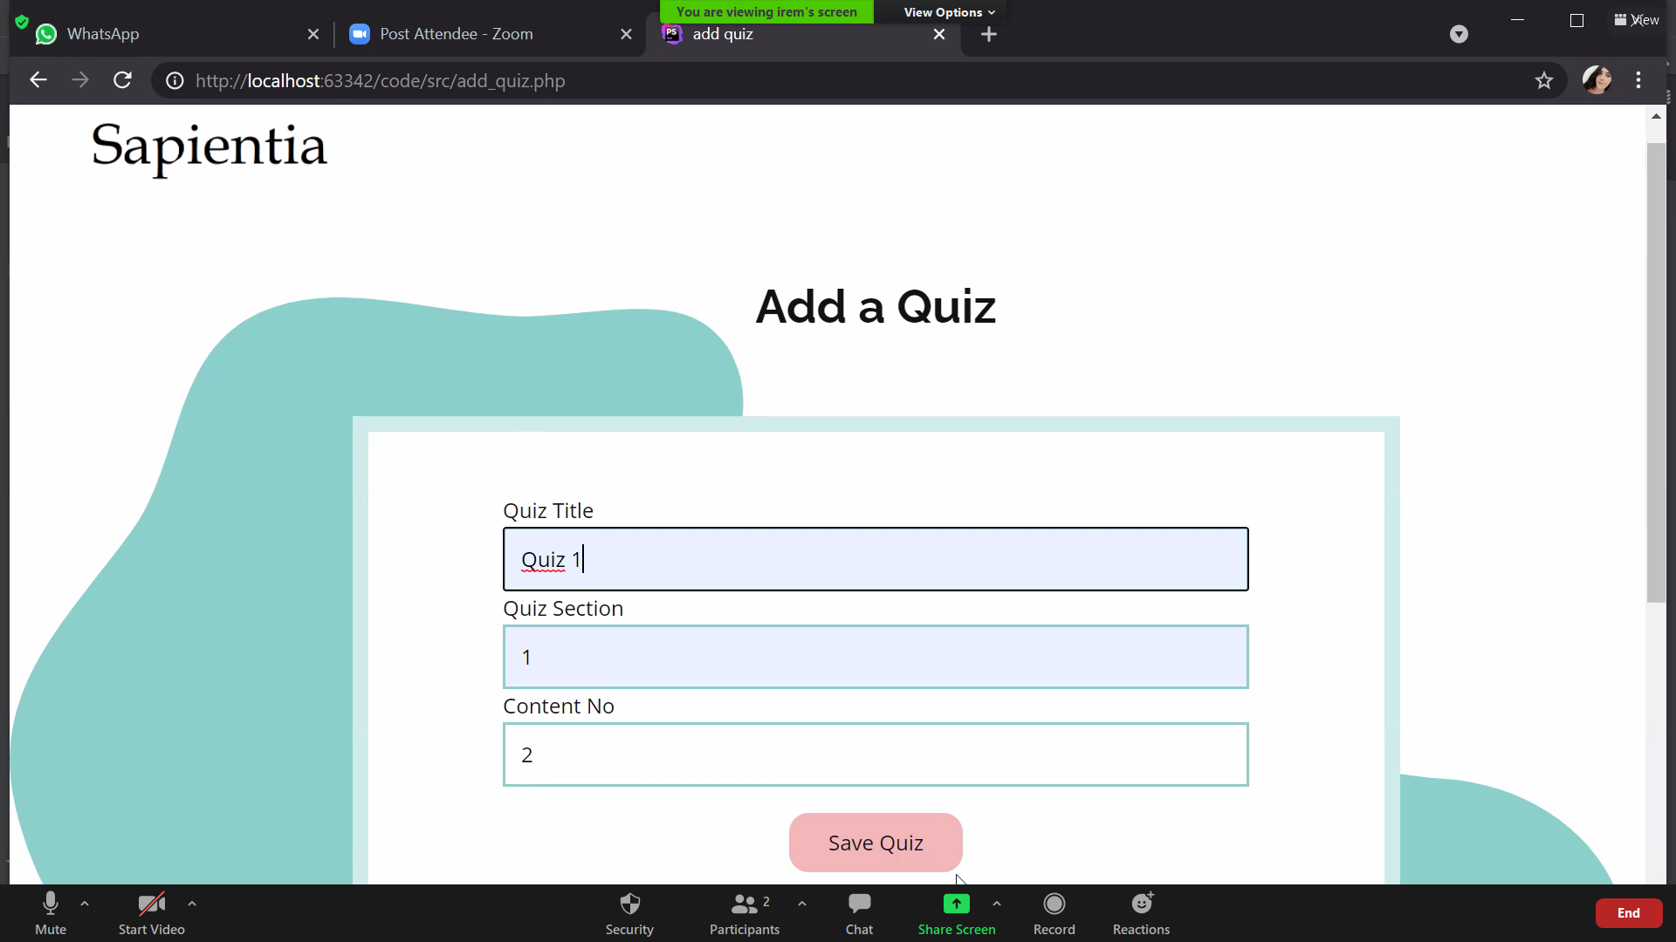

Fig .17 Adding a Quiz

After adding a quiz, instructor should add questions to that quiz. In **“Add a Quiz Question**” page, instructor should write a question, three options and indicate the correct answer of the question. Following that, the instructor can either continue adding questions or finish adding by pressing to the **“Finish”** button.

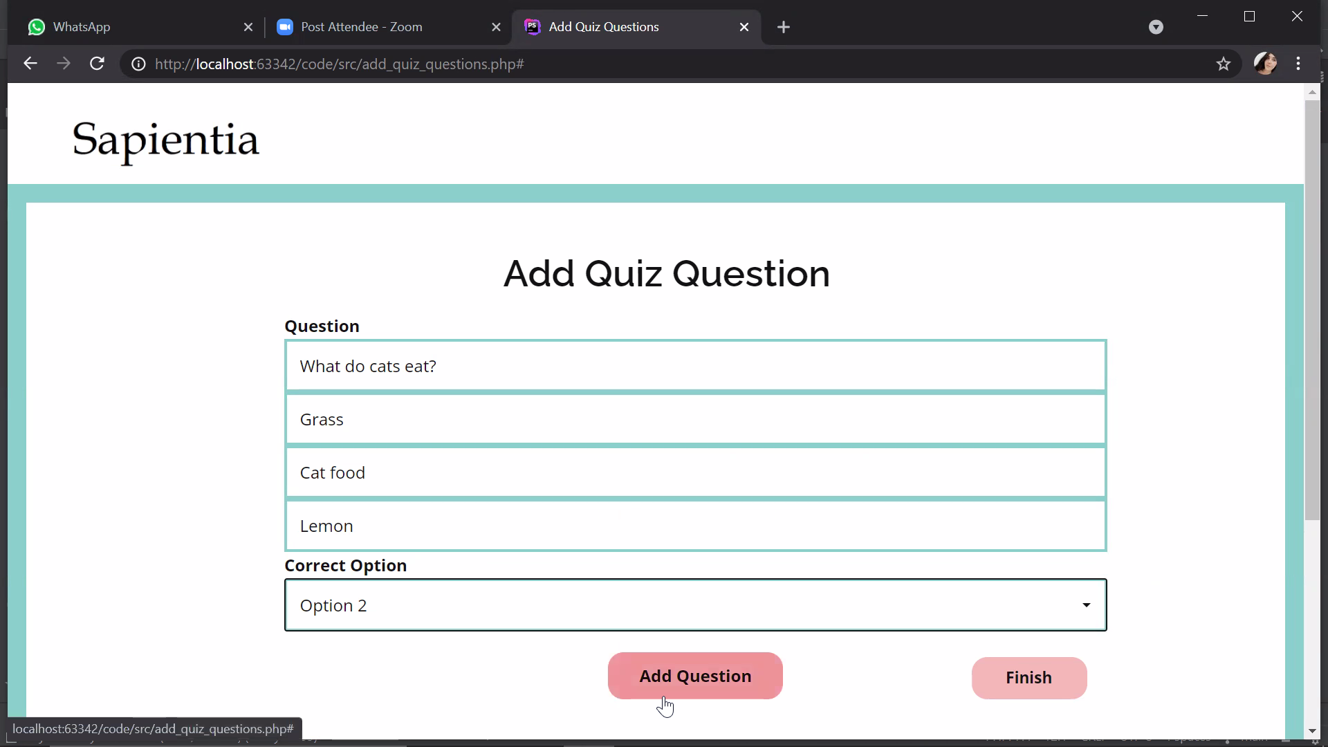

Fig 18. Adding Questions to a Quiz

#### 6.1.8 Inviting an Instructor to a Course

As an **additional feature,** instructors can invite other instructors to the course as content creators.In order to do this, the instructor should press the **“Invite an Instructor”** button on the “**Edit Course**” page. The button will direct the instructor to the page shown below. From there, the instructor should give the name and email address of the other instructor in order to add him/her as the content creator.

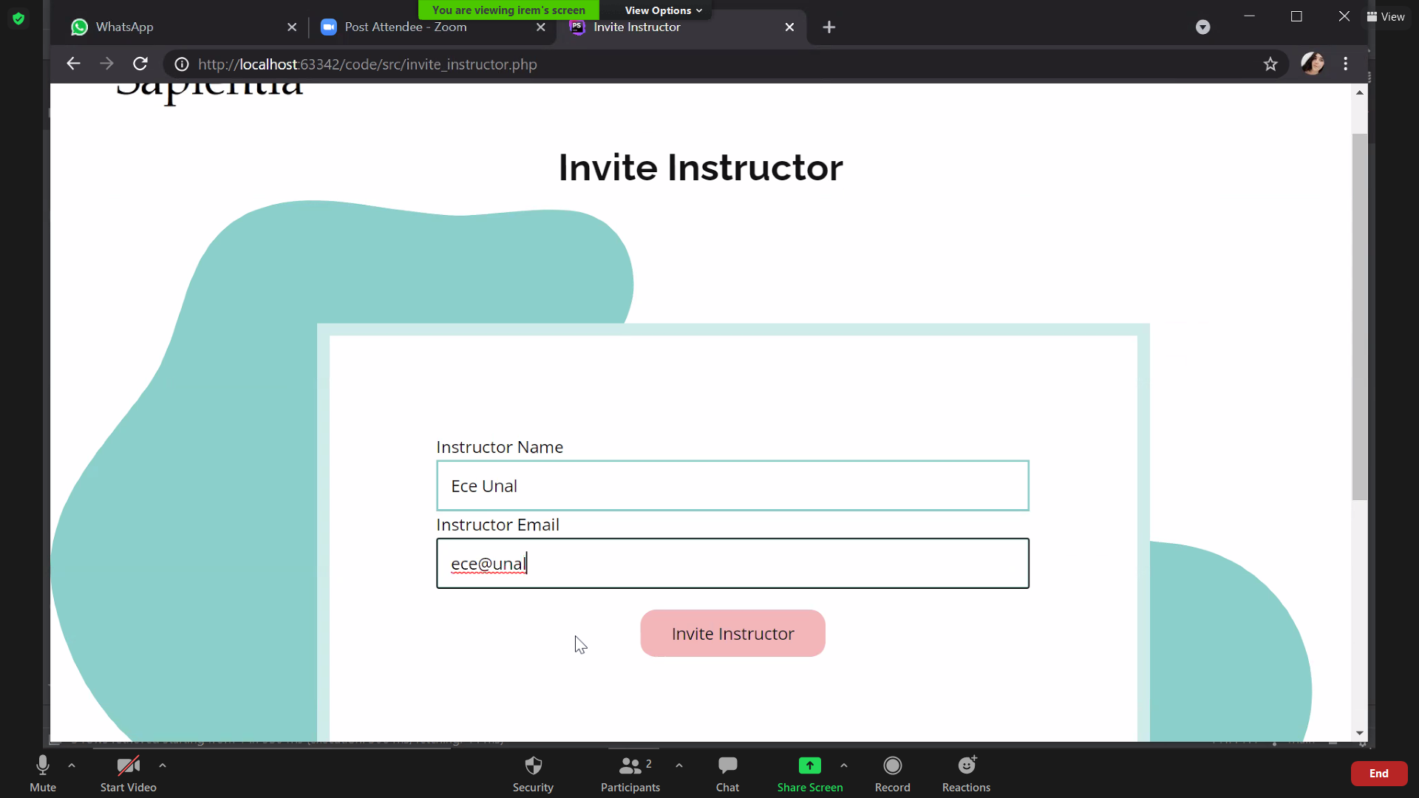

Fig 19. Inviting Another Instructor to the Course.

#### 6.1.9 Filing a Complaint About a Course

An instructor can add a complaint such as a technical issue about his/her course to the admin. In order to fill a complaint, he/she needs to press to the **“Fill a Complaint”** button which is next to the course’s name in the main page. From this page, the instructor must specify a subject, date and a brief description about the complaint and press to the **“Send Complaint”** button.

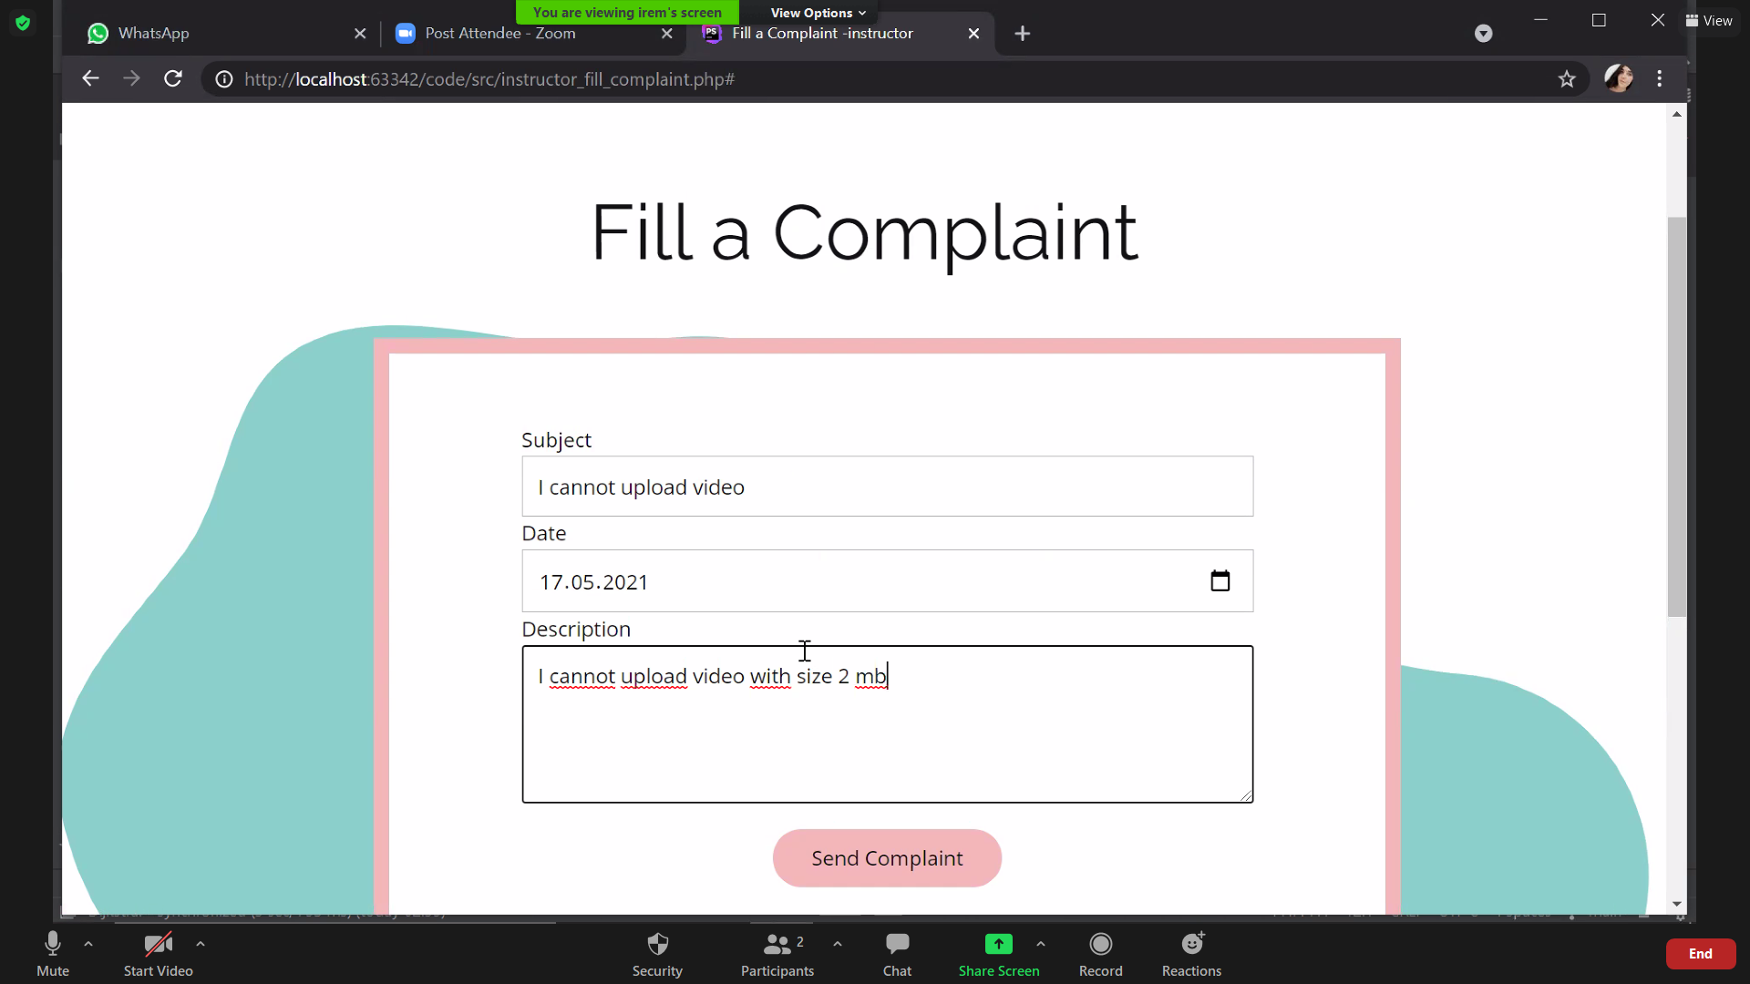

Fig 20. Filing a Complaint About a Course

#### 6.1.10 Making an Announcement About a Course

An instructor can make an announcement about his/her course to the enrolled students. In order to make it, he/she needs to press the **“Announce”** button which is next to the course’s name on the main page. The button will direct the instructor to the “Make Announcement” page. From there, the instructor should specify a subject, date and a description about the announcements.

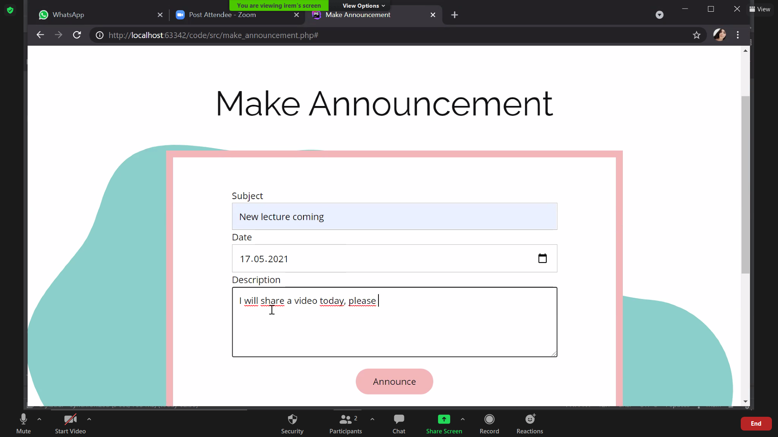

Fig 21. Making an Announcement About a Course

An instructor can see all of his/her announcements in the Sapientiae system by pressing the **“My Announcements”** button in the navigation bar. From there, the instructor can also delete any announcement by pressing to the **“DELETE”** button.

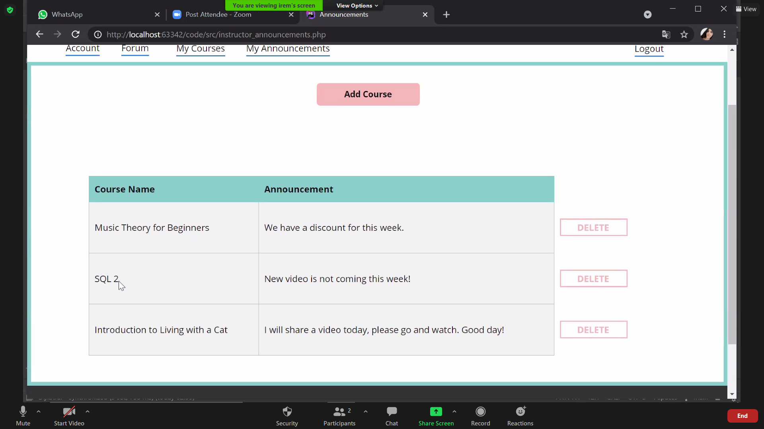

Fig 22. My Announcements Page

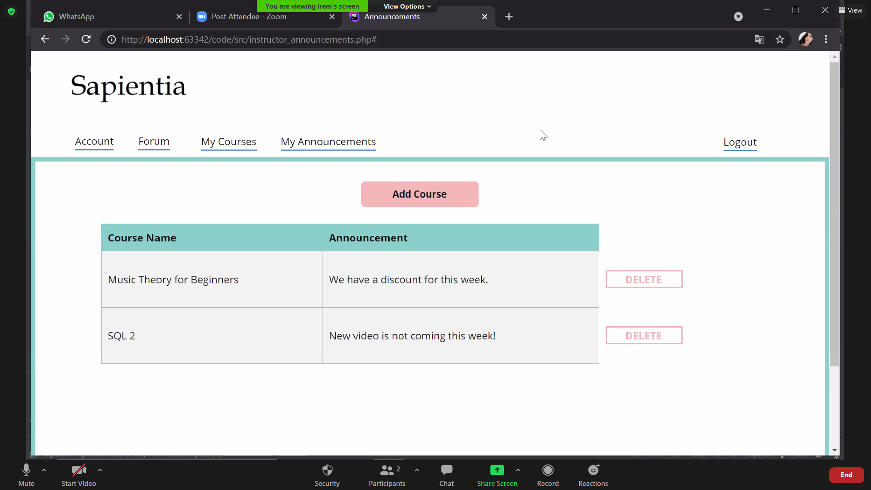

Fig 23. My Announcements Page After Deleting the Announcement About the Course “Introduction to Living with a Cat”

#### 6.1.11 Forum

An instructor can see all the questions from enrolled students about his/her courses from the **“Forum”** button in the navigation bar. From there, the instructor can answer any question about his courses by simply pressing to the **“Answer Question”** button next to the question itself.

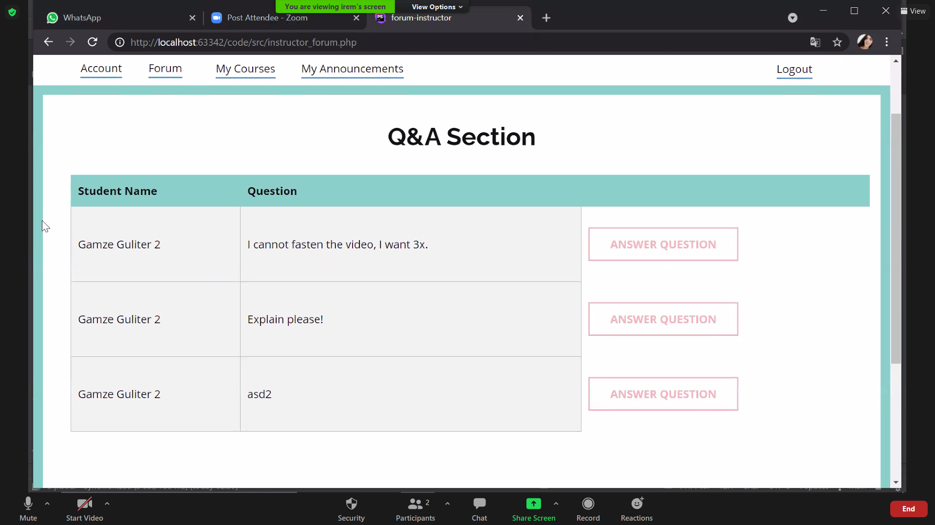

Fig 24. Instructor’s Forum Page

After pressing the **“Answer Question”** button, the instructor will be directed to the **“Answer the Question”** page. From there the instructor can submit an answer for the enrolled student’s question about a course.

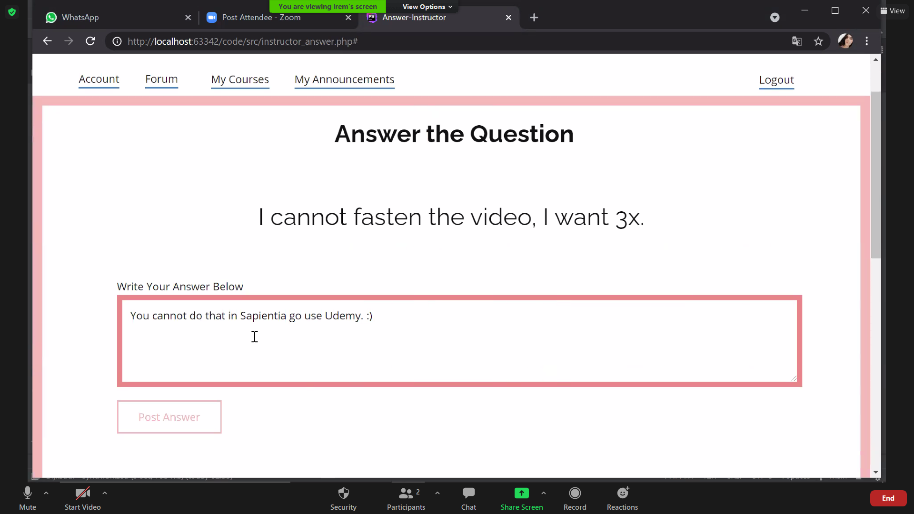

Fig 25. Answer the Question Page

#### 6.1.12 Statistics

An instructor can see the statistics about his/her courses such as the average student rating, number of enrolled students and the number of refund requests about the course. In order to see the **“Statistics”** page, the instructor should press to the **“Statistics”** button which is next to the course’s name in the main page.

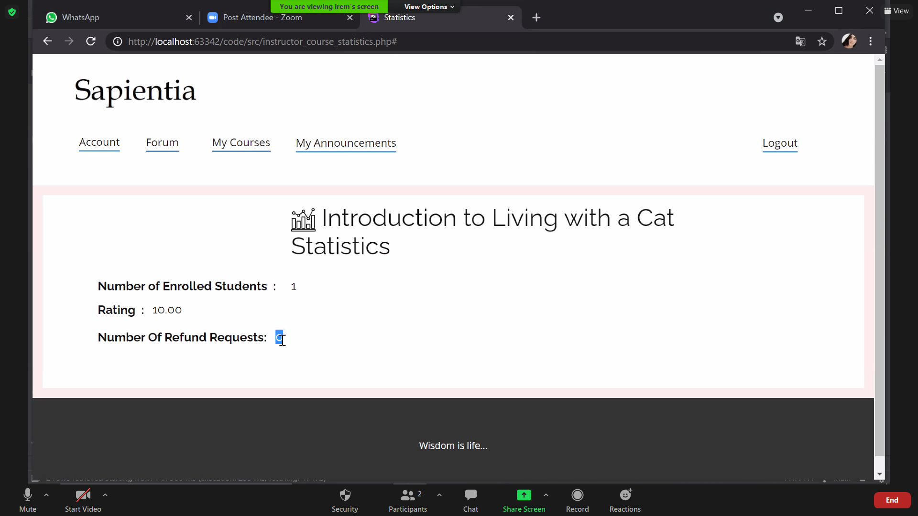

Fig 26. Statistics about the Course “Introduction to Living with a Cat”

## 6.2. Student User Manual

#### 6.2.1 Student Login

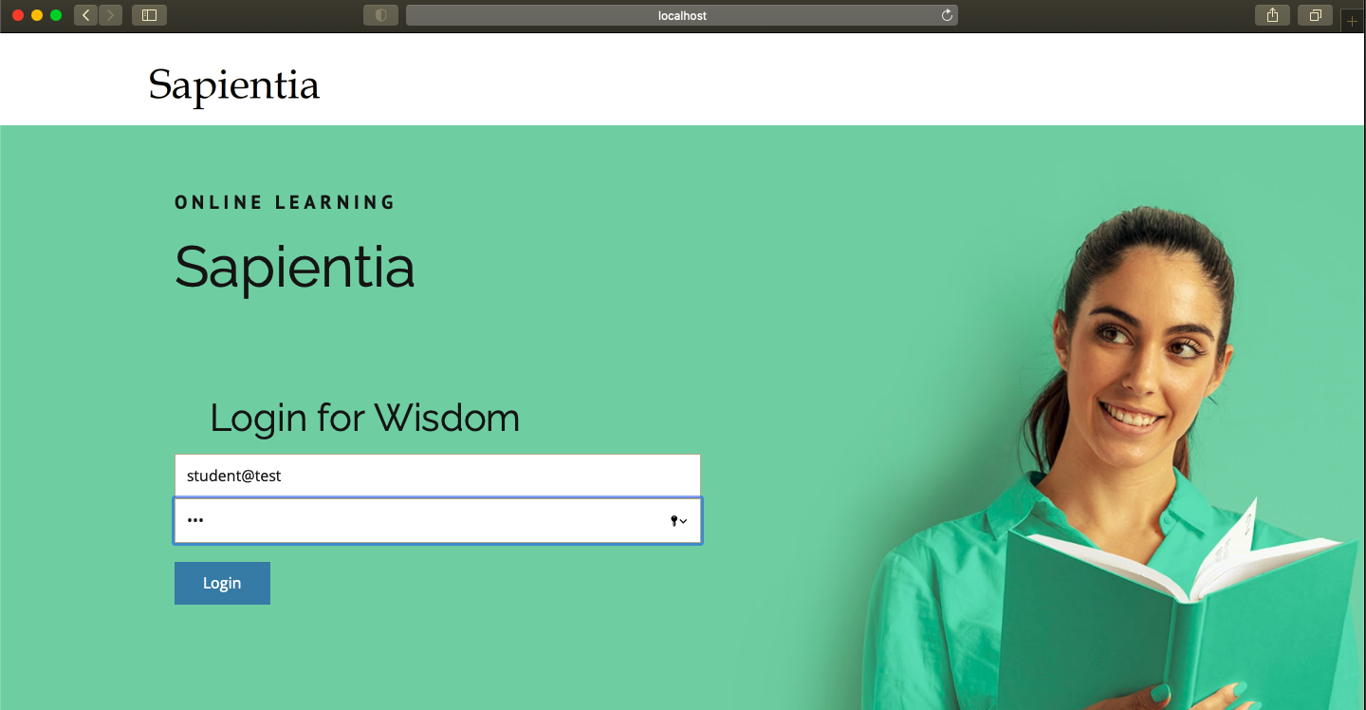

#### 6.2.2 Student’s Main Page

Before filtering:

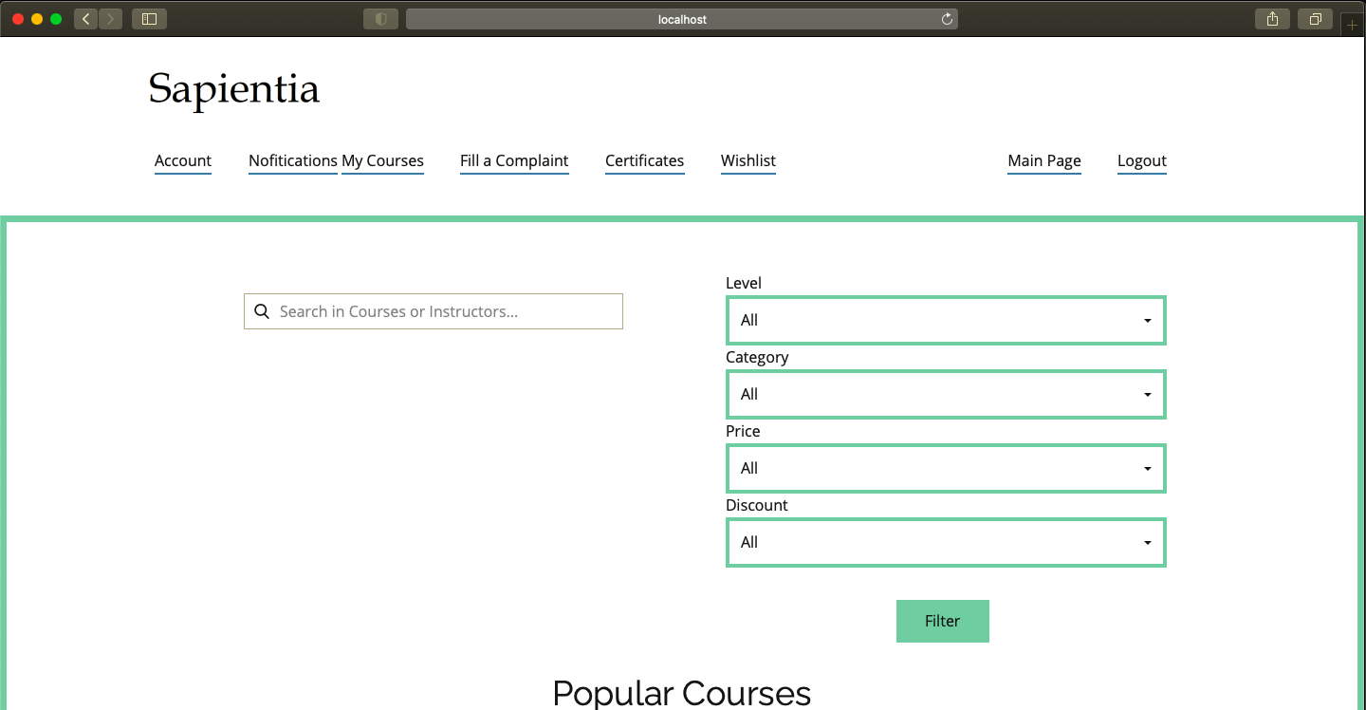

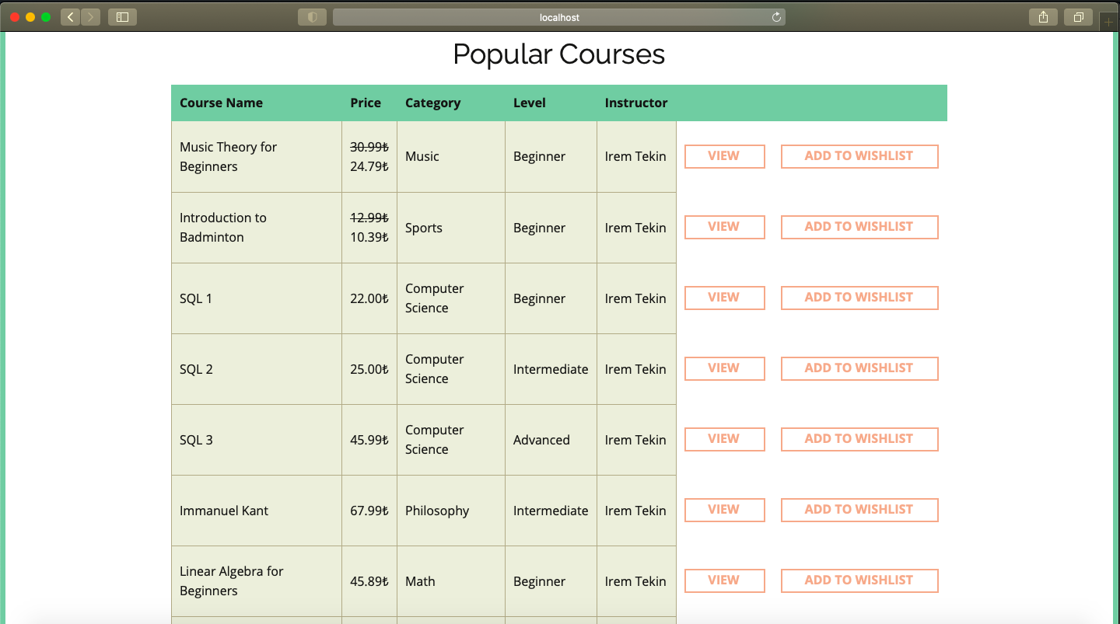

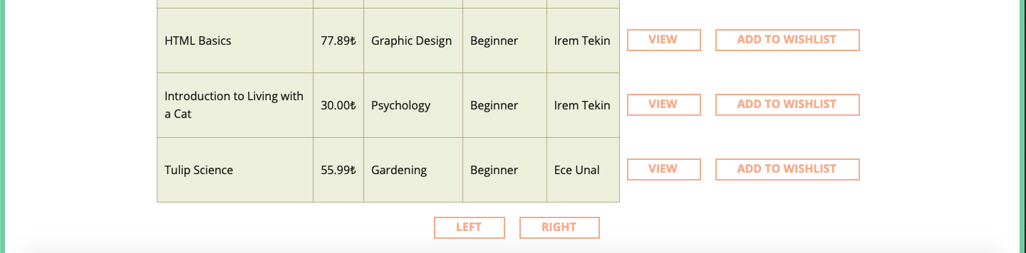

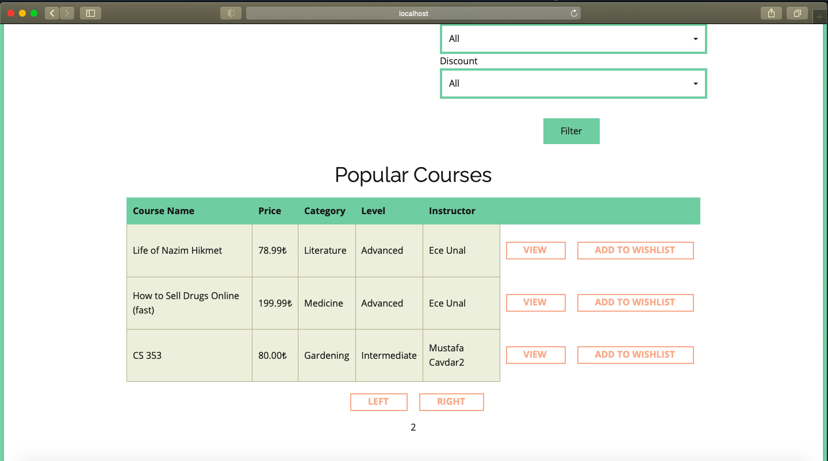

After filtering with the keyword ‘sql’:

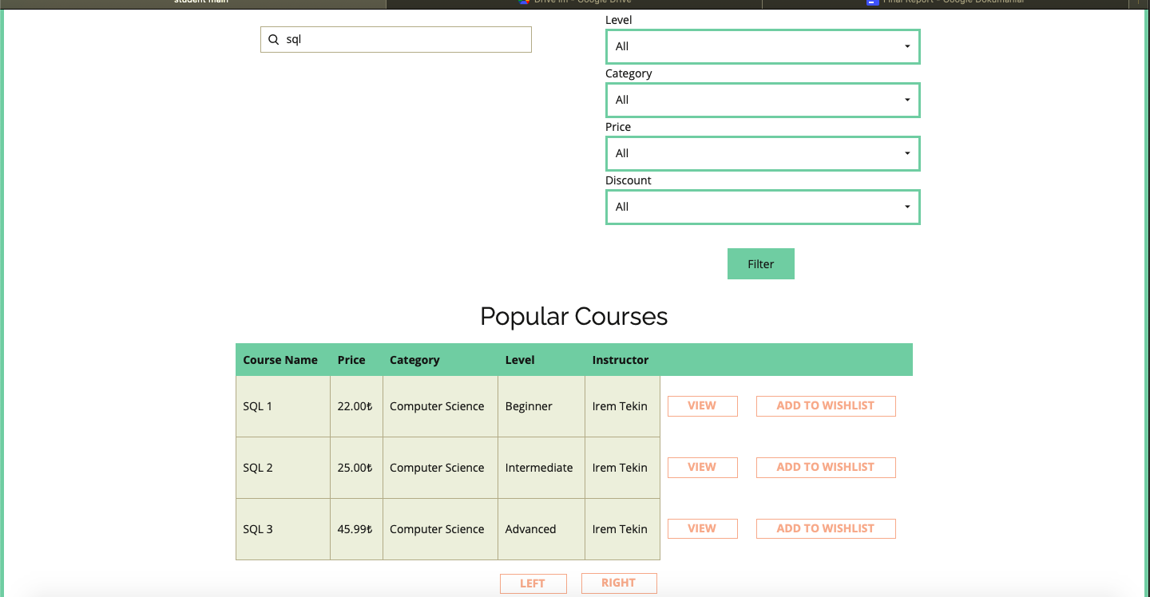

Listing only advanced level courses:

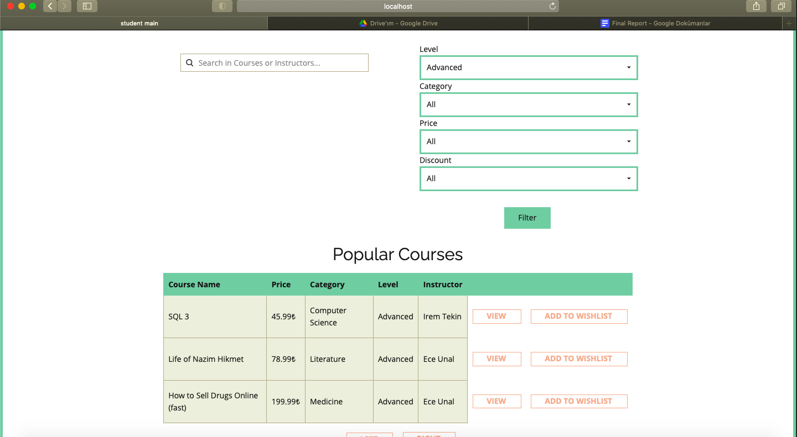

Listing advanced courses in Computer Science category:

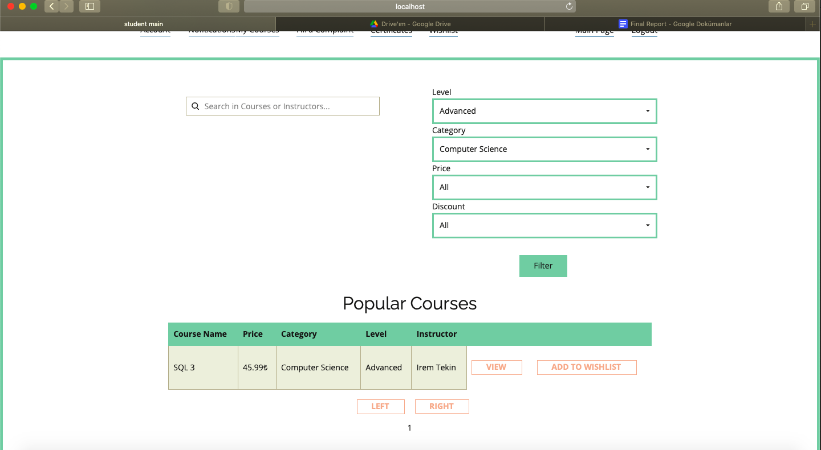

Listing courses between prices 35-50 liras:

Listing courses between prices 35-50 liras and includes “sql” keyword:

#### 6.2.3 Course Page

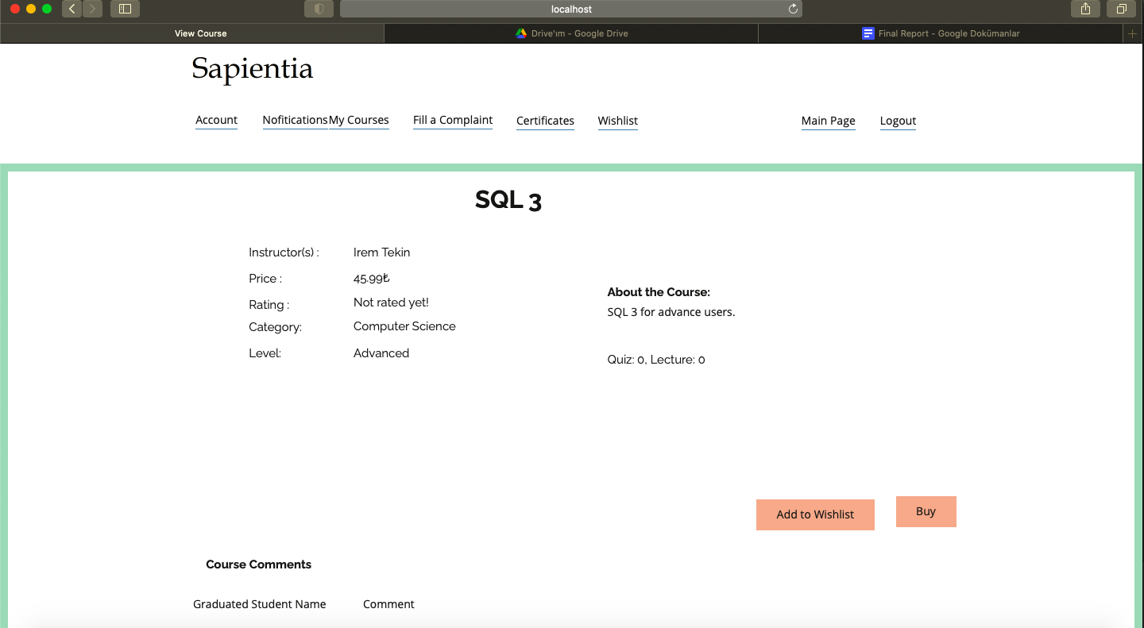

7.2.4 After Buying the Course - Course Page

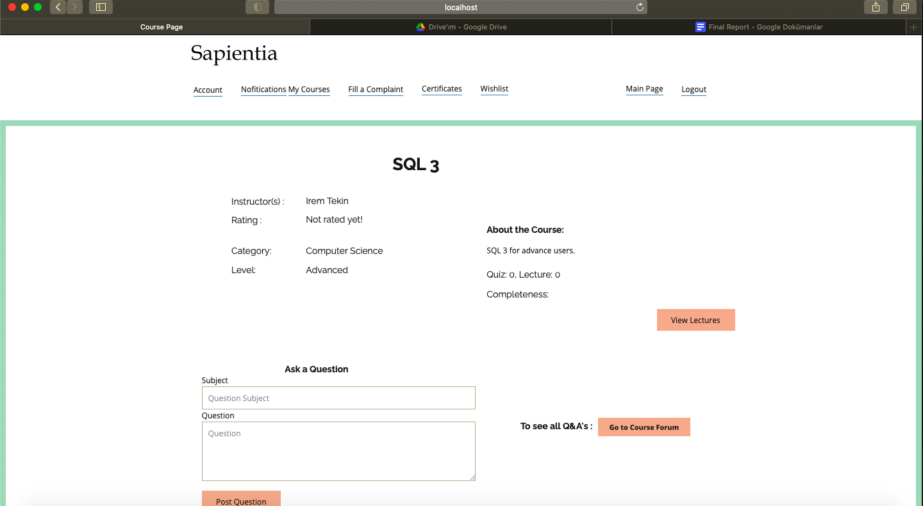

Asking question:

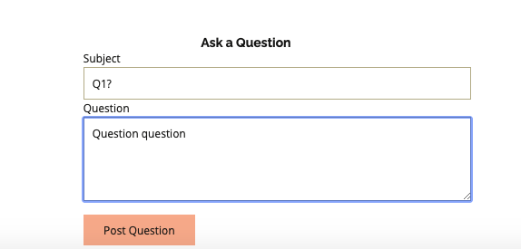

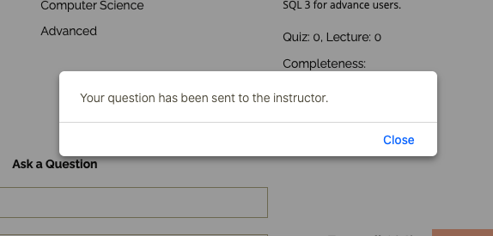



7.2.5 Course Forum

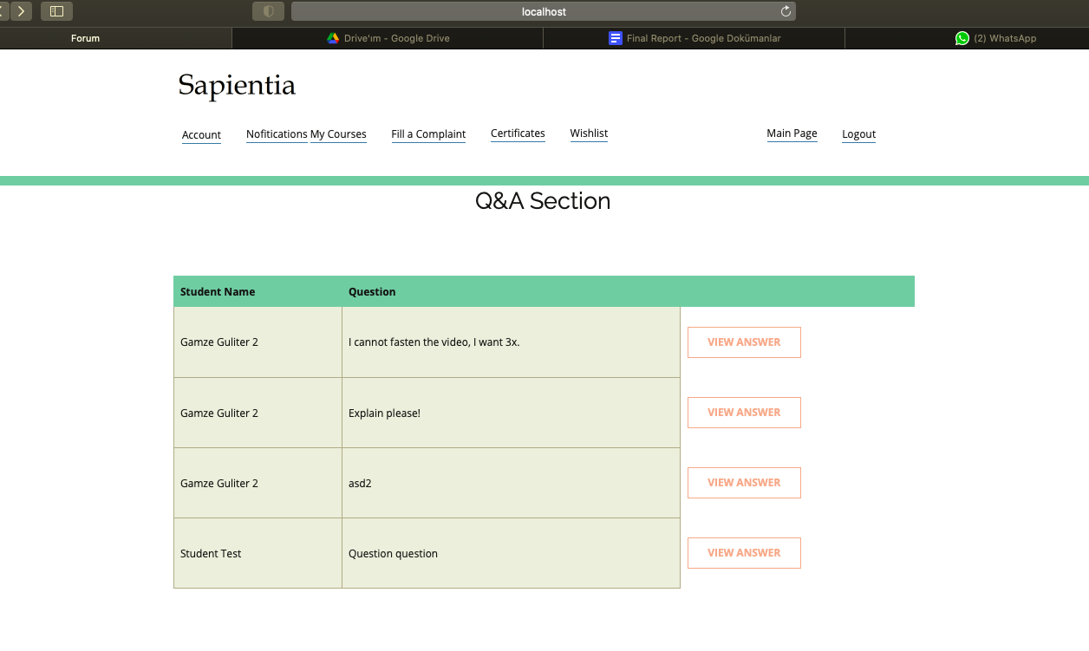

7.2.5 Answer to a forum question

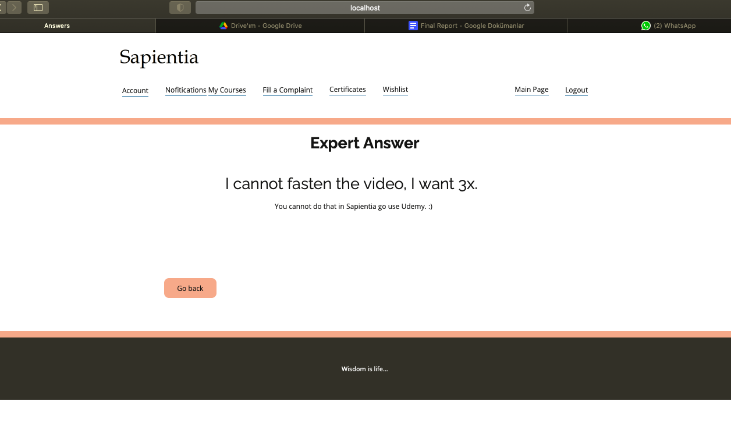

7.2.5 Course Forum

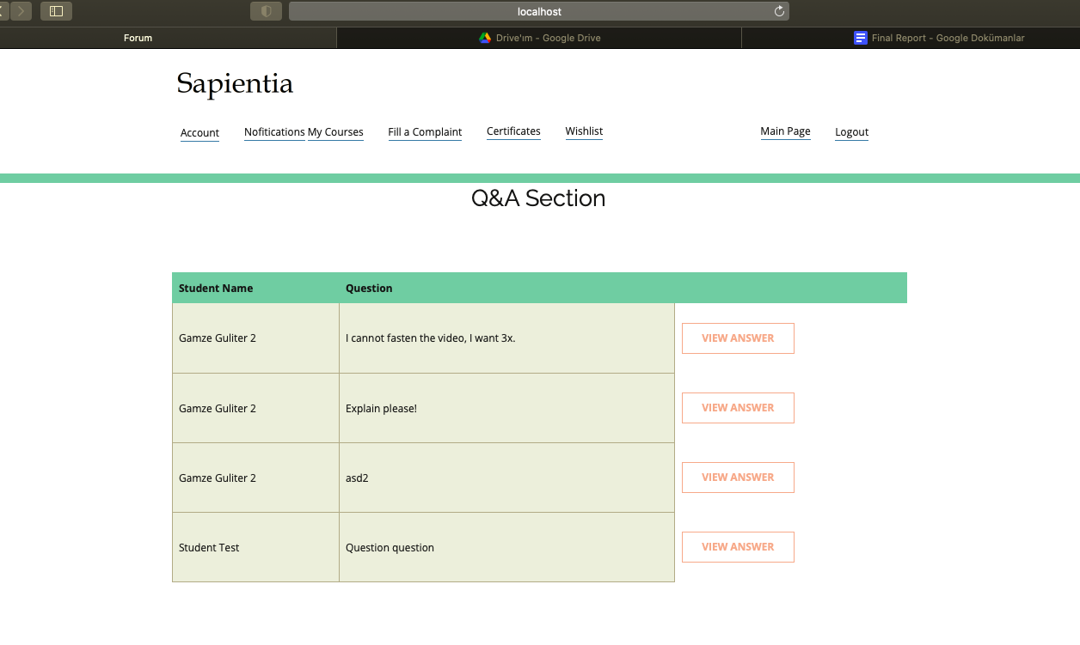

## 6.3. Admin User Manual

#### 6.3.1 Admin Login

Sapientia admin can login to the system using the login page.

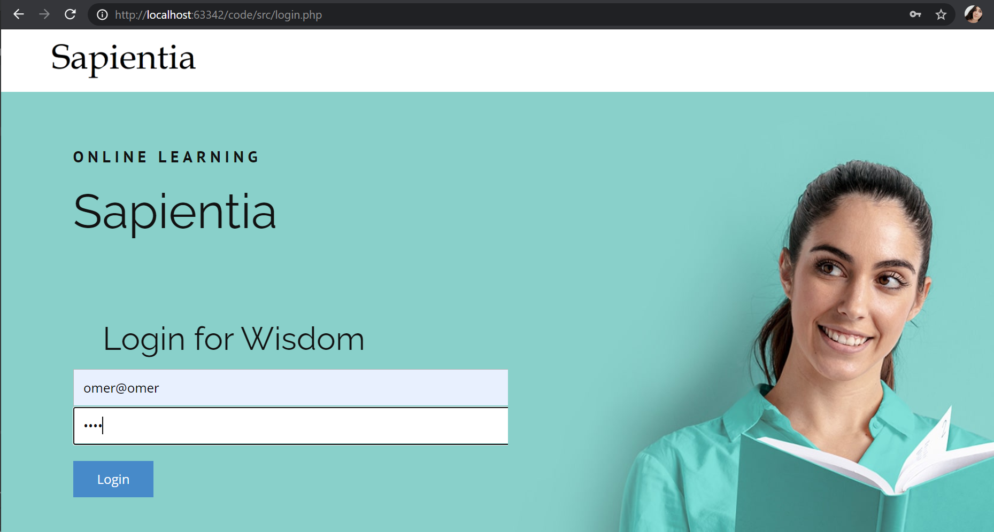

Fig. X. Admin Login

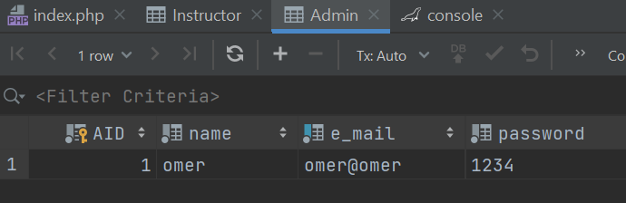

Fig. X. Admin Table

#### 6.3.2 Admin Main Page and Filtering

Sapientia admin sees a main page which consists of all courses that are added by instructors. Admin can filter the courses, view the courses statistics and offer discount using this page.

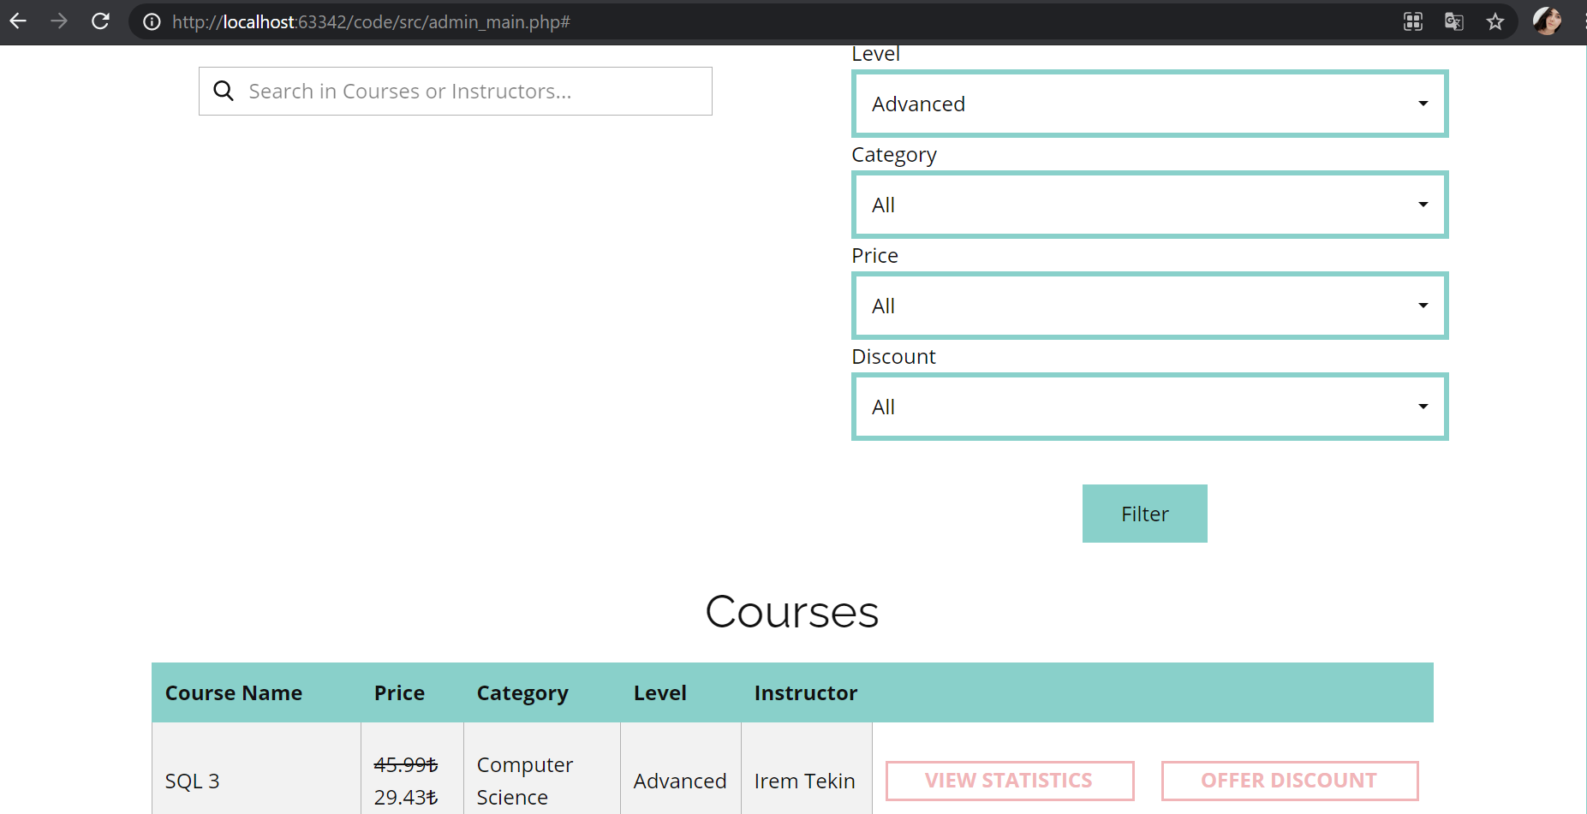

Fig. X. Admin Main Page and Filtering

#### 6.3.3 View Course Statistics

Admin can view the statistics about a course by clicking the **view statistics button**. In statistics page, the number of students who enrolled the course, the rating of the course and the number of refund requests for the course are displayed.

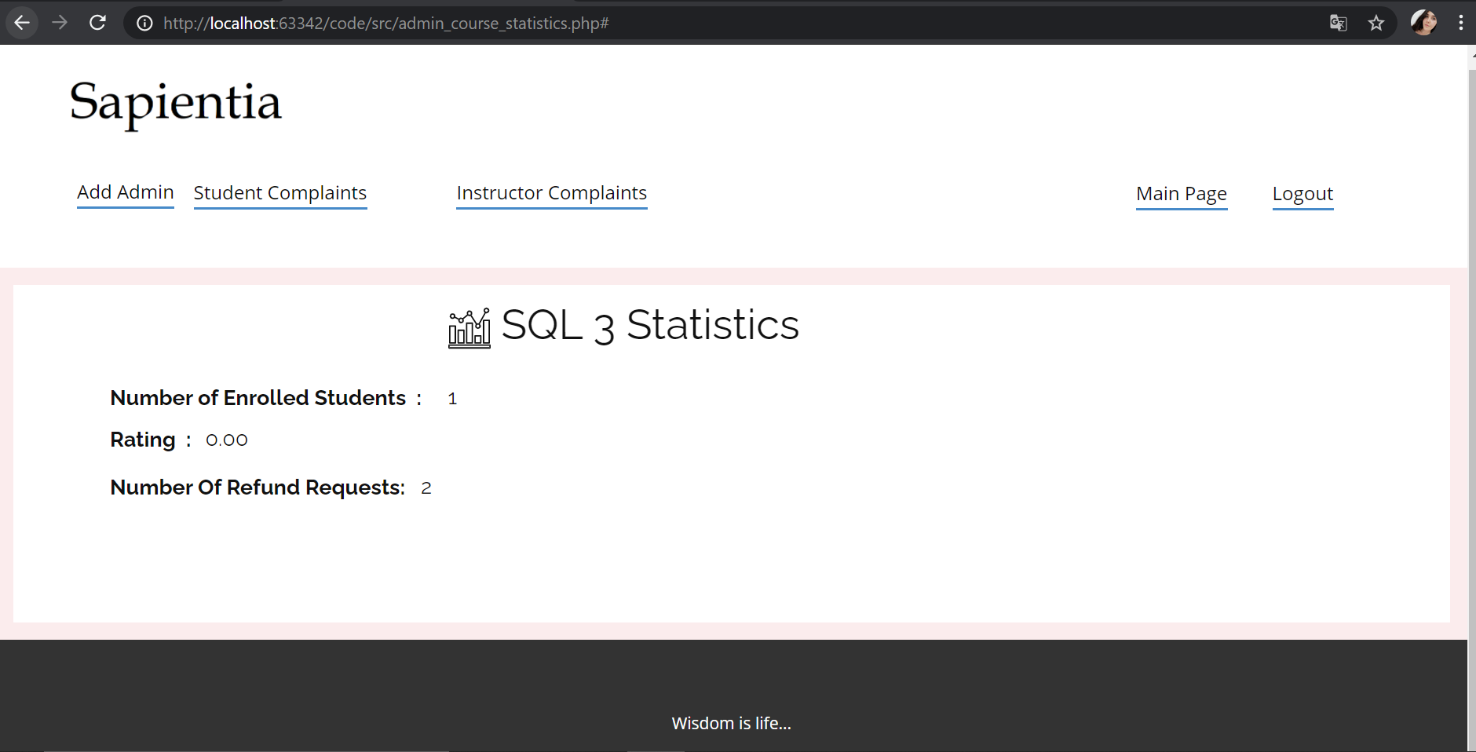

Fig. X. View Course Statistics

#### 6.3.4 Discount Management - Apply Discount

In the main page, the **offer discount button** is displayed for the courses that are allowed to get discounts. Admin can manage discounts of a course by clicking the **offer discount button**. The button leads admin to course’s price and discount information. Admin can change the discount rate or delete the discount. To apply discount, admin writes a new discount rate, selects apply discount and saves changes. The change in the price of the course is displayed on the main page.

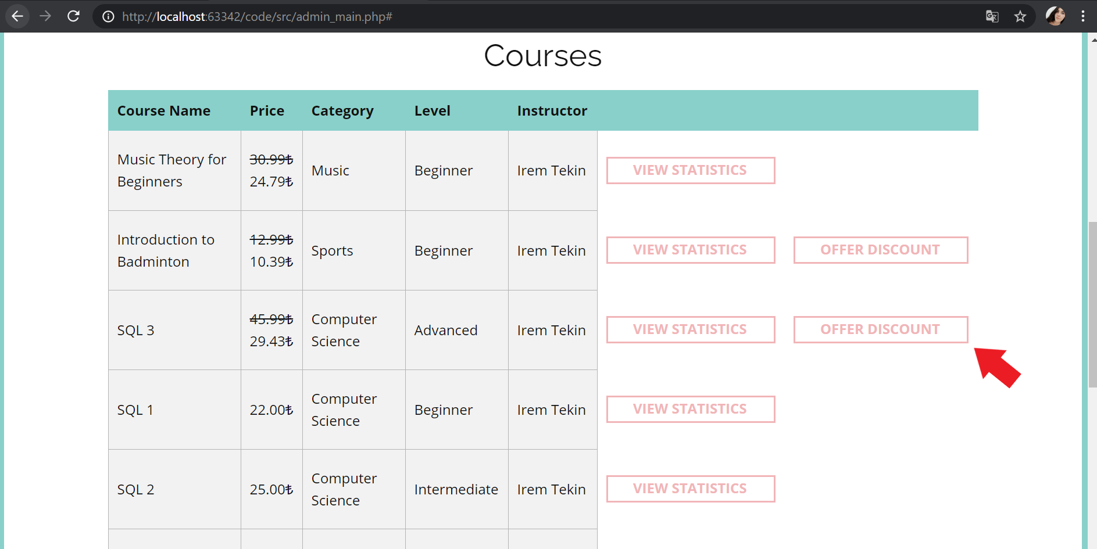

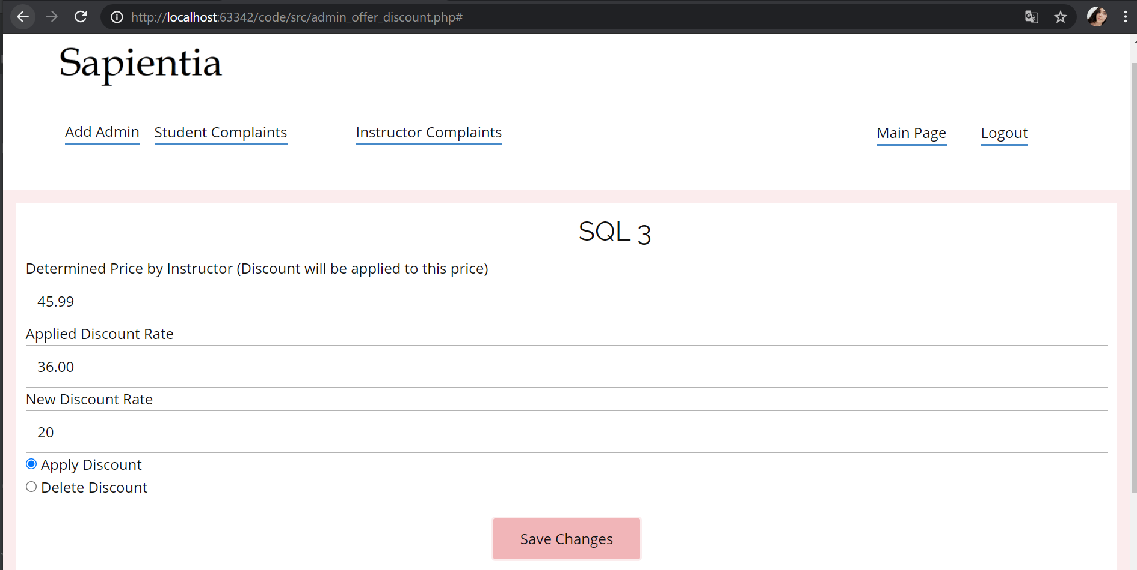

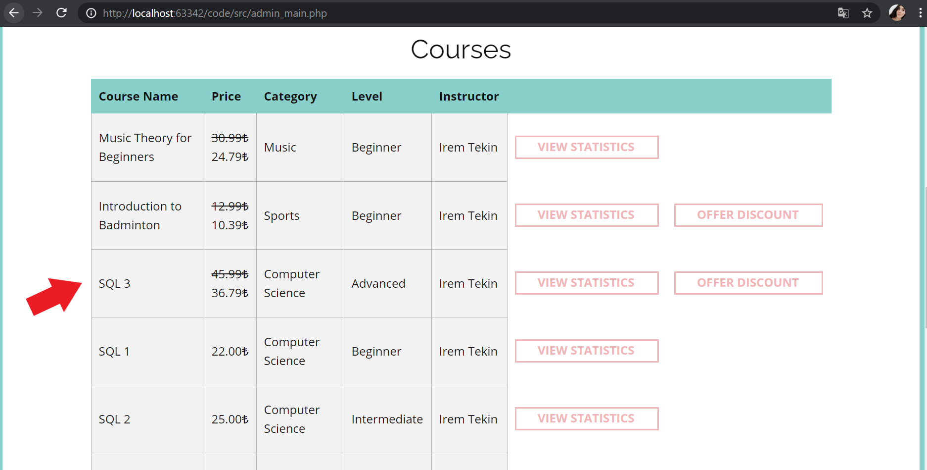

Fig. X. , X. and X. Apply Discount

#### 6.3.4 Discount Management - Delete Discount

Admin can also delete an already applied discount by selecting delete discount and select changes. The change in the price of the course is displayed on the main page.

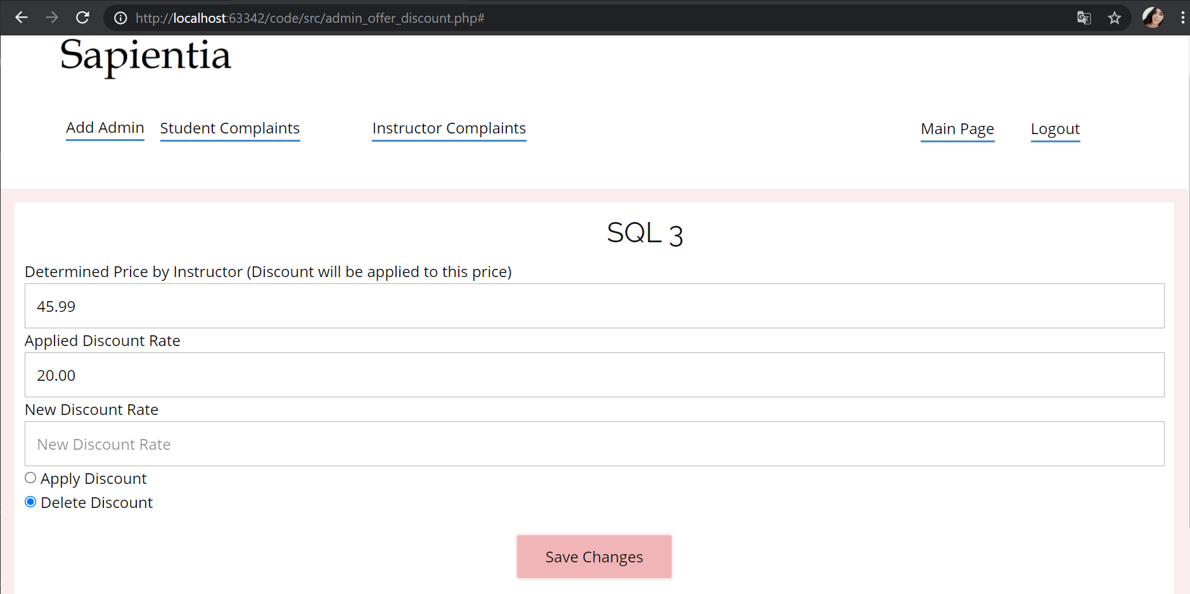

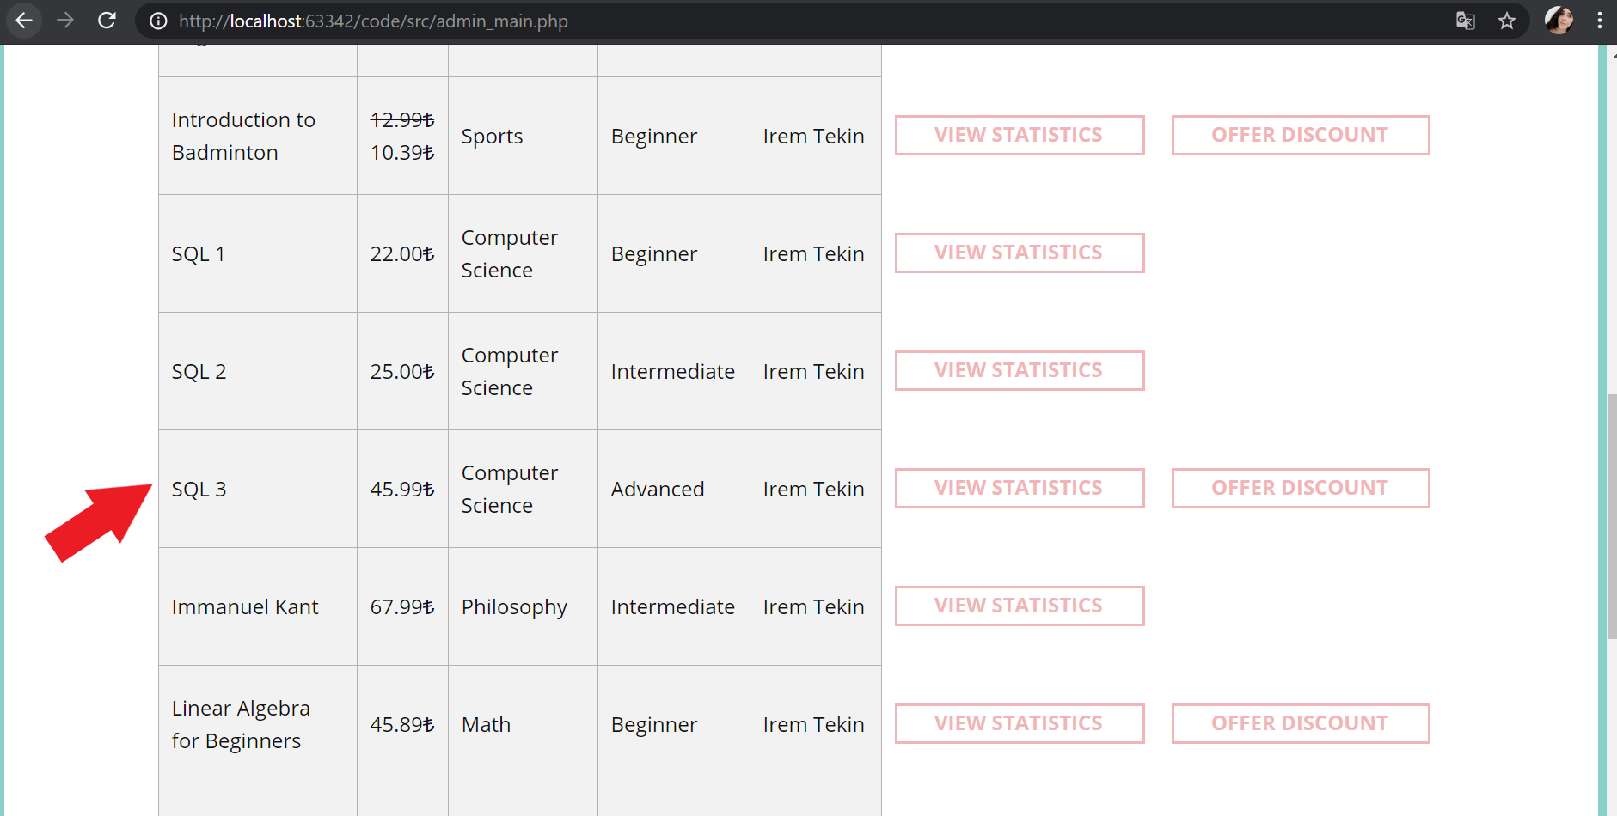

Fig. X. and X. Delete Discount

#### 6.3.5 Manage Student Complaints

Students can complain about courses, in their complaints can ask for a refund or not. Admin can view all the complaints by clicking **Student Complaints butto**n in the header. If a student asks for a refund, **refund button** is displayed next to the student complaint. If student doesn’t ask for a refund, **noted button** is displayed next to **ignore button**.

#### 6.3.5.1 Ignore Student Complaint

Admin can ignore a complaint by clicking **ignore button**. When admin ignores the complaint the complaint is deleted.

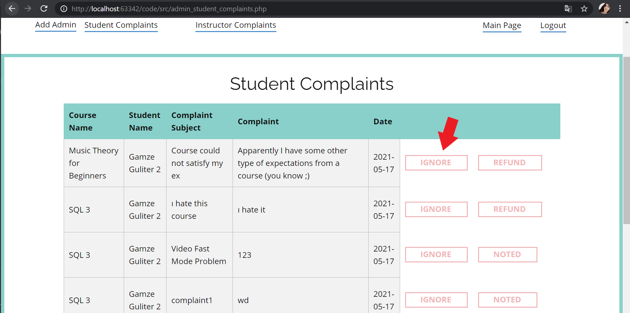

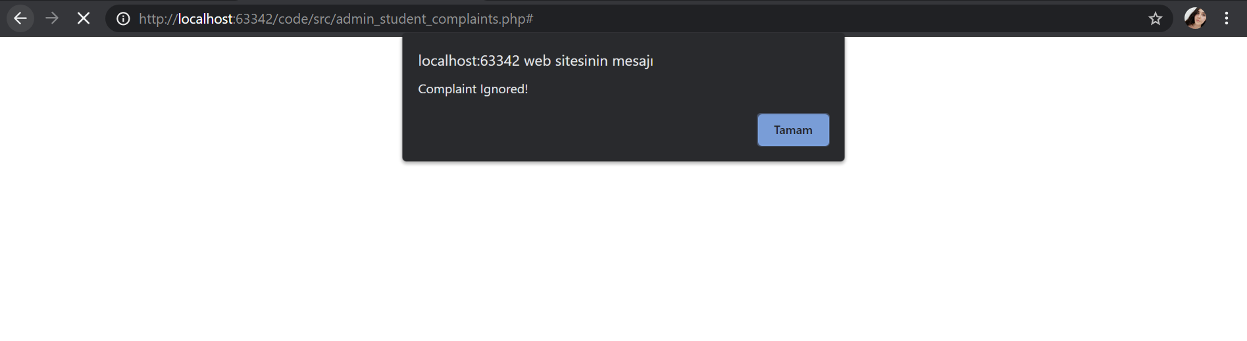

Fig. X. and X. Ignore Student Complaint

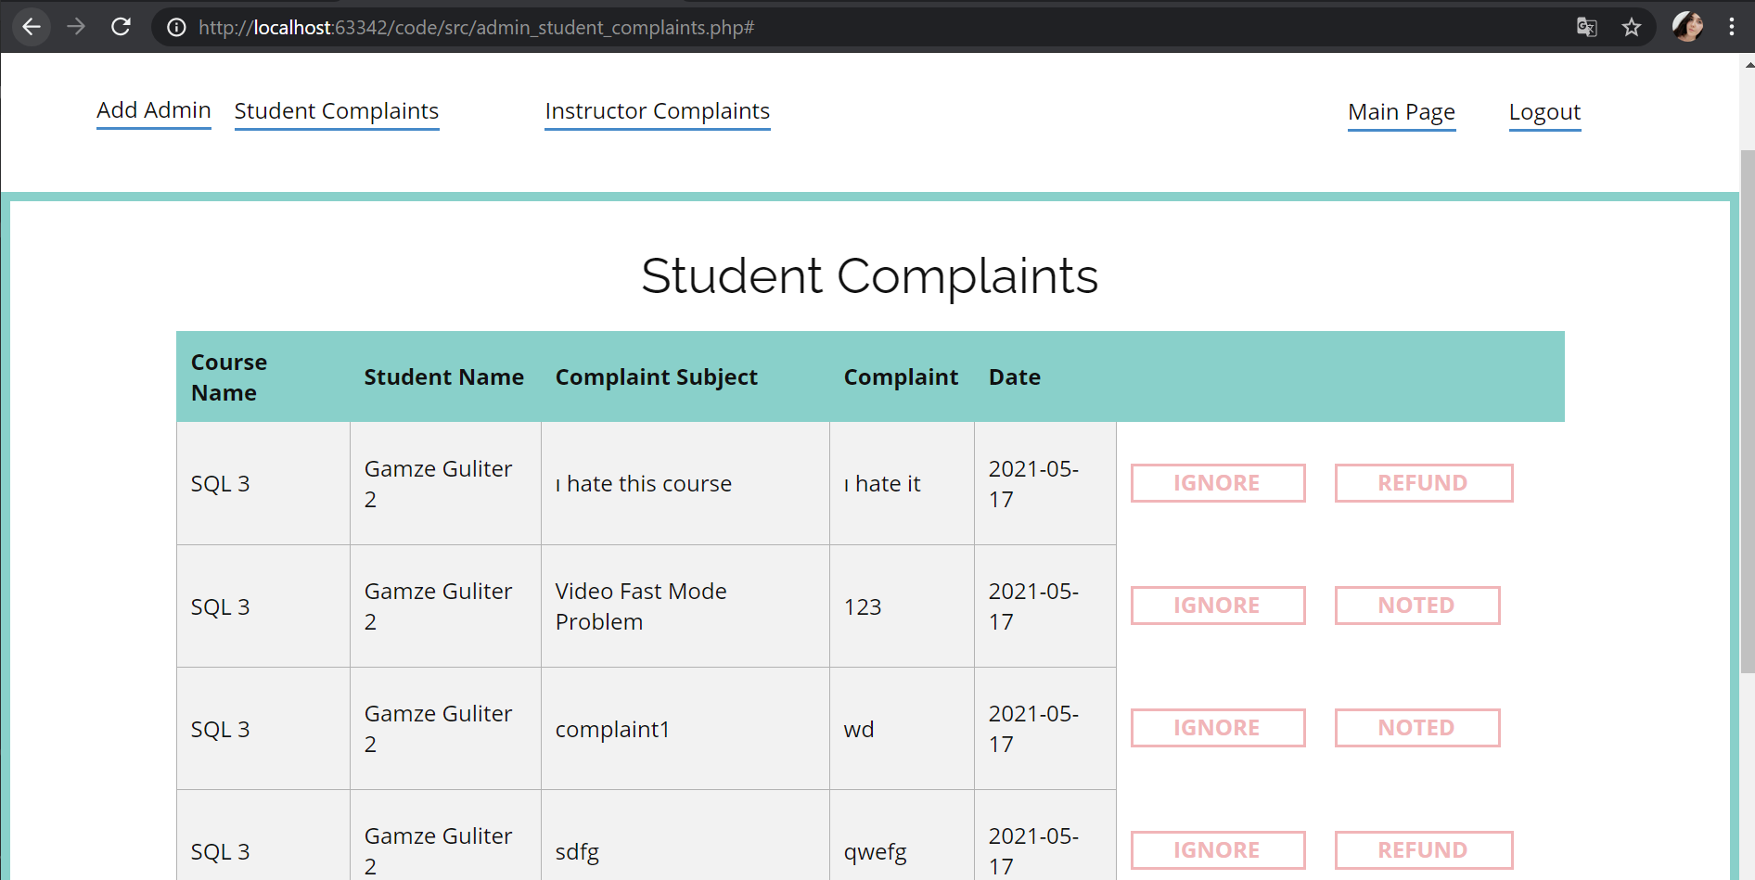

Fig. X. After ignore Student Complaint

#### 6.3.5.2 Note Student Complaint

Admin can use **noted button** if admin doesn’t want to ignore a complaint which doesn’t include a refund request.

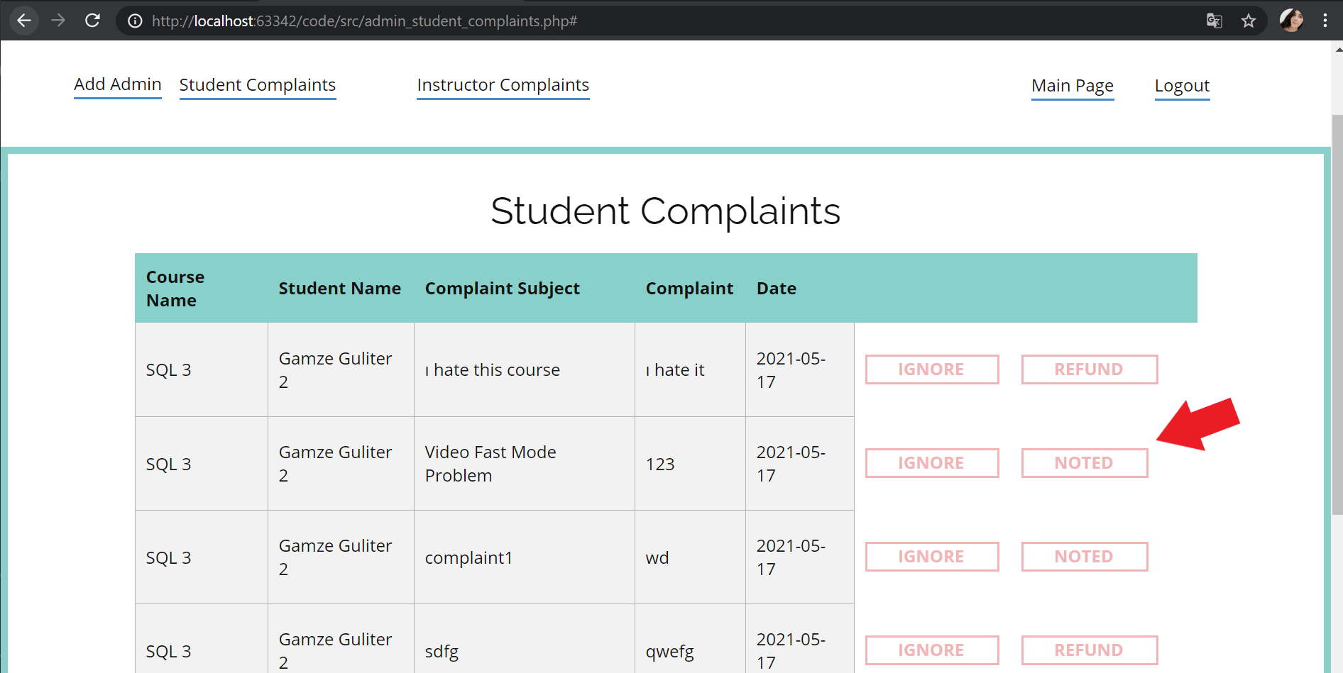

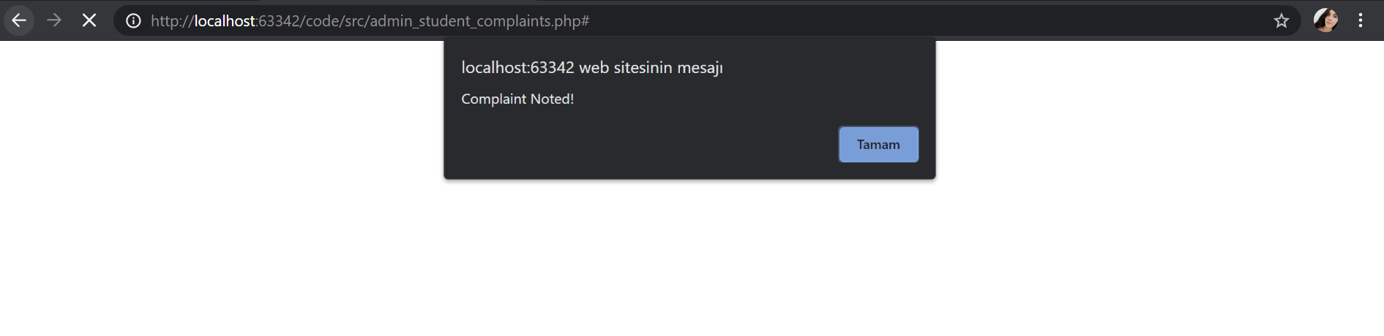

Fig. X. and X. Note Student Complaint

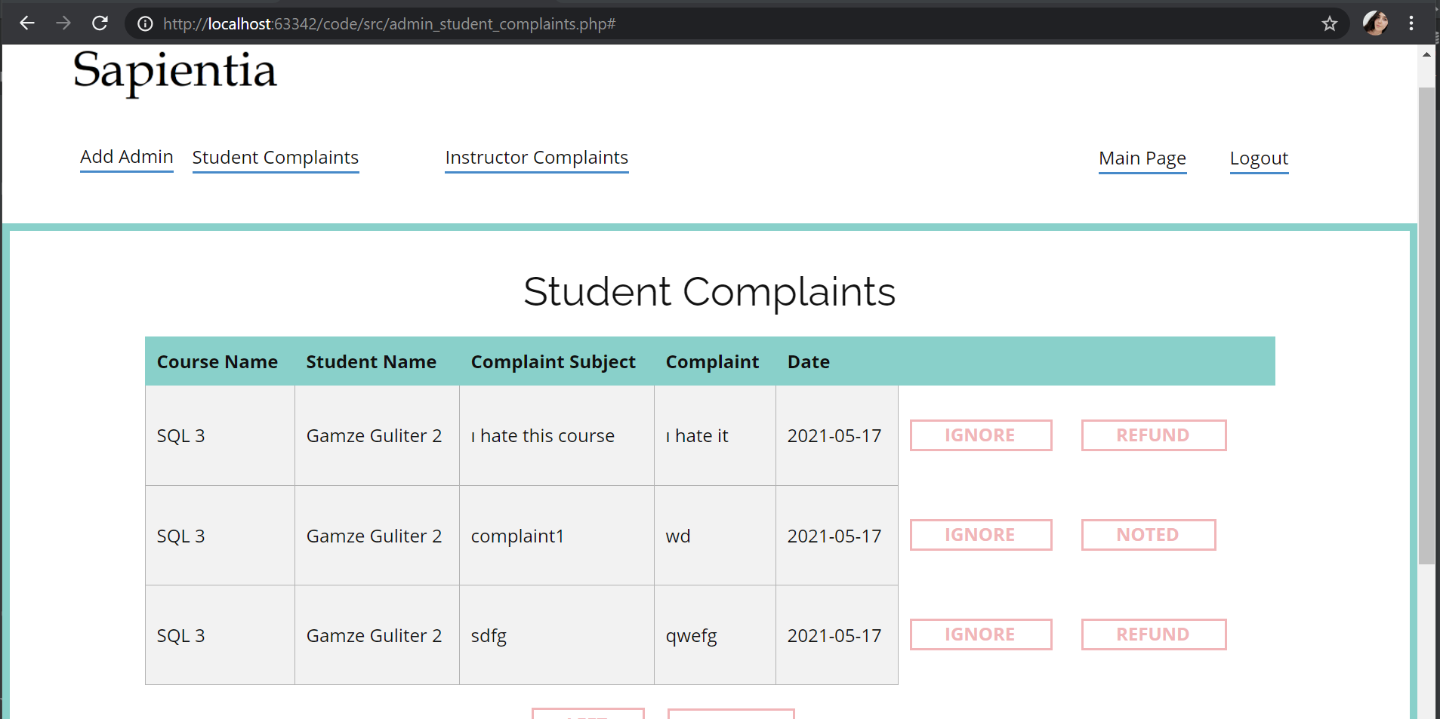

Fig. X. After Note Student Complaint

#### 6.3.5.3 Refund Student

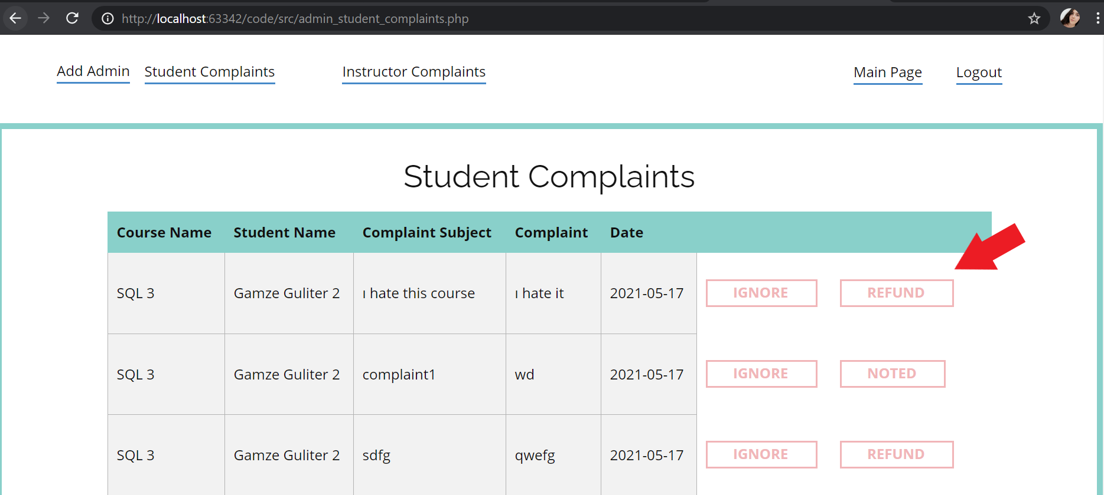

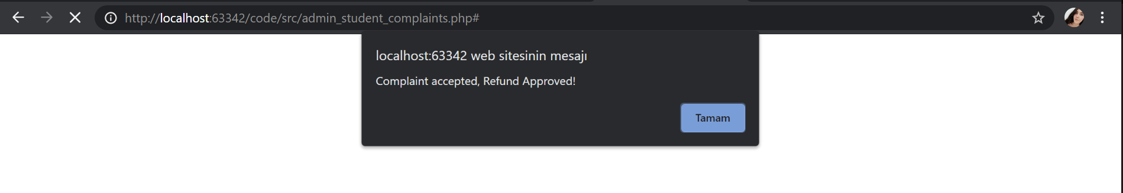

Fig. X. and X. Refund Student

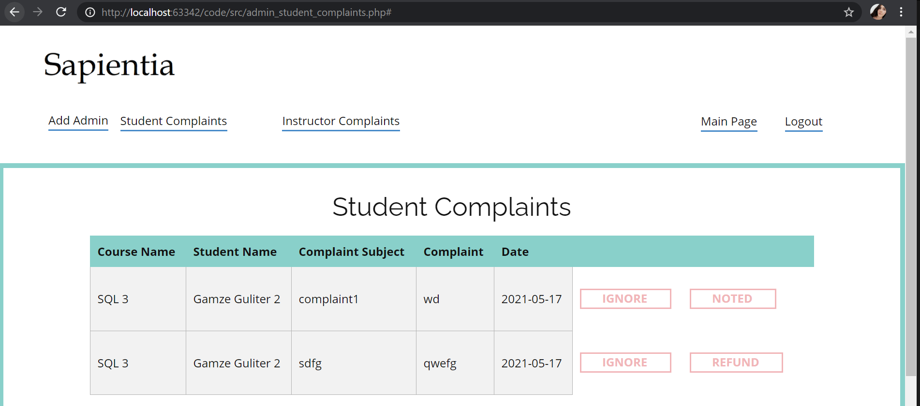

Fig. X. After Refund

#### 6.3.6 Manage Instructor Complaints

Instructors can complain about their courses to admin. Admin can ignore or note the complaints.

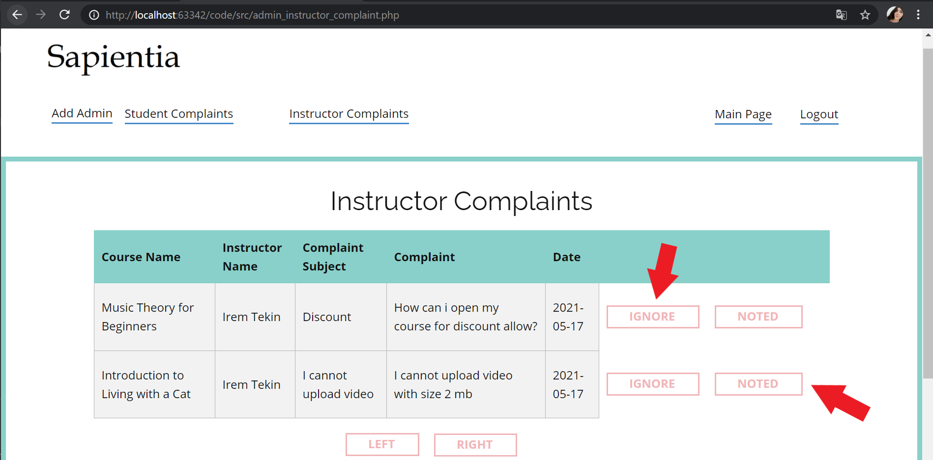

Fig. X. Ignore and Note the Complaints

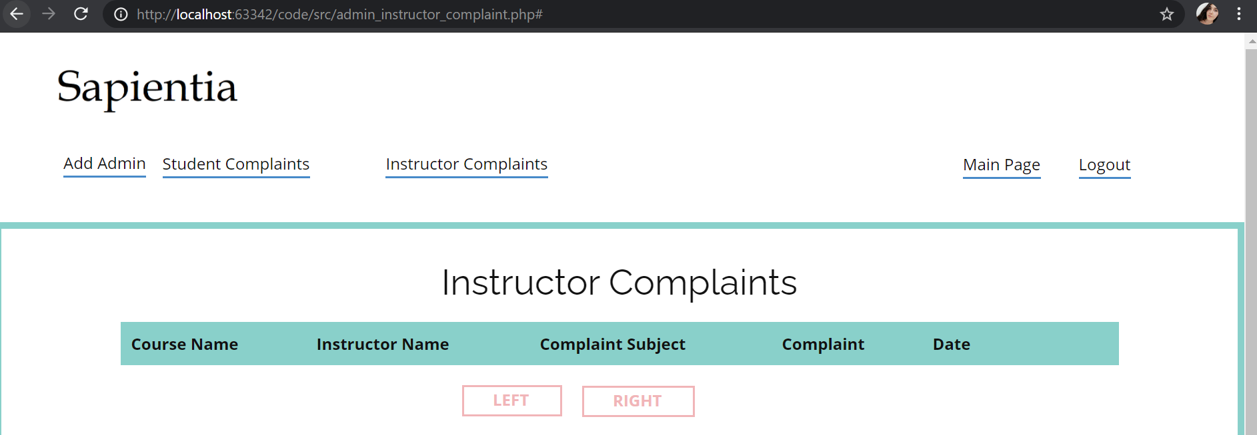

Fig. X. After Ignore and Note the Complaints

#### 6.3.7 Add Admin

An admin can add other admins by clicking the **add admin button** in the header and giving information about a new admin.

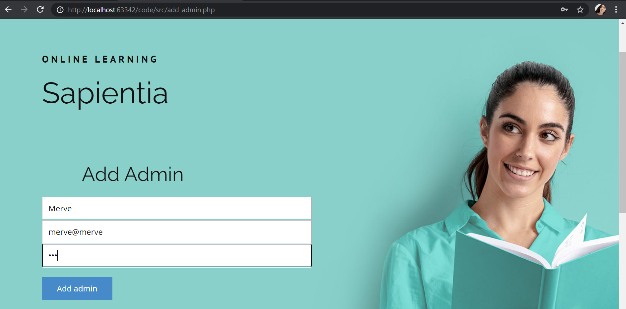

Fig. X. Add Admin

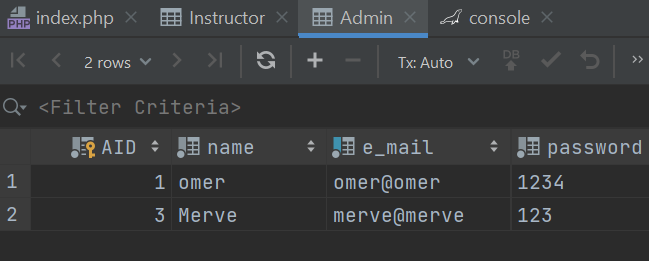

Fig. X. Admin Table

# 7. Website

The link of GitHub page of the project is the following:

<https://github.com/Sapientia-Course-Platform/CS353_Project>

The link of Reports Website is the following:

<https://sapientia-course-platform.github.io/CS353_Project/>

# 8. References

# 9. Appendix

## 8.1. SQL Create Table Code

use omer_unlusoy;  
  
DROP TABLE IF EXISTS Take_Quiz_Question;  
DROP TABLE IF EXISTS Take_Lecture;  
DROP TABLE IF EXISTS Take_Quiz;  
DROP TABLE IF EXISTS Zoom_Session;  
DROP TABLE IF EXISTS Discount;  
DROP TABLE IF EXISTS Evaluates_Complaint_Entry_Student;  
DROP TABLE IF EXISTS Evaluates_Complaint_Entry_Instructor;  
DROP TABLE IF EXISTS Teaches;  
DROP TABLE IF EXISTS Enrolls;  
DROP TABLE IF EXISTS Wishlist;  
DROP TABLE IF EXISTS Certificate;  
DROP TABLE IF EXISTS QnA_Entry_Student;  
DROP TABLE IF EXISTS QnA_Entry_Instructor;  
DROP TABLE IF EXISTS Complaint_Entry_Student;  
DROP TABLE IF EXISTS Complaint_Entry_Instructor;  
DROP TABLE IF EXISTS Course_Announcement;  
DROP TABLE IF EXISTS Note;  
DROP TABLE IF EXISTS Quiz_Question;  
DROP TABLE IF EXISTS Quiz;  
DROP TABLE IF EXISTS Lecture;  
DROP TABLE IF EXISTS Section;  
DROP TABLE IF EXISTS Course;  
  
DROP TABLE IF EXISTS Student;  
DROP TABLE IF EXISTS Instructor;  
DROP TABLE IF EXISTS Admin;  
  
/*  
 General Assumptions:  
 ID -> INT AUTO_INCREMENT  
 referencing ID -> INT NOT NULL  
 short string -> VARCHAR(30)  
 mid string -> VARCHAR(50)  
 long string -> VARCHAR(70)  
 description -> VARCHAR(300)  
 money -> NUMERIC(12, 2) OR NUMERIC(8, 2)  
 % -> NUMERIC(5, 2)  
 date -> DATE  
 URL -> VARCHAR(1024)  
  
 Special Cases:  
 membership_type -> ENUM('BRZ', 'SLV', 'GLD')  
 refund_request -> BOOLEAN  
 duration -> TIME  
 lecture_content -> BLOB NOT NULL  
 membership_type -> ENUM('BRZ', 'SLV', 'GLD') NOT NULL DEFAULT 'BRZ'  
 answer -> ENUM('choice1', 'choice2', 'choice3') NOT NULL DEFAULT 'choice1'  
  
 Constraints:  
 Student-Course cannot be in Wishlist, Enrolls, and Certificate all together.  
 adds Wishlist -> Enrolls (remove from Wishlist) -> get Certificate (add Certificate not remove Enrolls)  
 Lecture and Quiz content_num  
  
 Future:  
 ENGINE = InnoDB; can be added  
  
 */  
  
  
/*  
 Assumptions:  
*/  
CREATE TABLE Student(  
 SID INT AUTO_INCREMENT,  
 name VARCHAR(50) NOT NULL,  
 e_mail VARCHAR(50) NOT NULL UNIQUE,  
 password VARCHAR(30) NOT NULL,  
 membership_type ENUM('BRZ', 'SLV', 'GLD') NOT NULL DEFAULT 'BRZ',  
 PRIMARY KEY (SID)  
);  
  
/* Assumptions:  
 include functions [course_count(), current_income()]  
*/  
CREATE TABLE Instructor(  
 IID INT AUTO_INCREMENT,  
 name VARCHAR(50) NOT NULL,  
 e_mail VARCHAR(50) NOT NULL UNIQUE,  
 password VARCHAR(30) NOT NULL,  
 PRIMARY KEY (IID)  
);  
  
CREATE TABLE Admin(  
 AID INT AUTO_INCREMENT,  
 name VARCHAR(50) NOT NULL,  
 e_mail VARCHAR(50) NOT NULL UNIQUE,  
 password VARCHAR(30) NOT NULL,  
 salary NUMERIC(12, 2) NOT NULL DEFAULT 0.00,  
 PRIMARY KEY (AID)  
);  
  
/* Assumptions:  
 include functions [rating(), student_count(), lecture_count()]  
 constraints for category and level  
 0 <= cost <= 999,999.99  
 discount_allowed = True OR False  
 lecture_completed_threshold = %70  
 0 <= certificate_threshold <= 100.00  
 attention: FOREIGN KEY (creator_IID) REFERENCES Instructor(IID) ON DELETE NO ACTION ON UPDATE CASCADE  
 UNIQUE (creator_IID, course_name)  
*/  
CREATE TABLE Course(  
 CID INT AUTO_INCREMENT,  
 IID INT NOT NULL,  
 course_name VARCHAR(70) NOT NULL,  
 description VARCHAR(300),  
 rating NUMERIC(5, 2) DEFAULT 0.00,  
 category VARCHAR(30),  
 level VARCHAR(30),  
 cost NUMERIC(8, 2) NOT NULL DEFAULT 0.00,  
 discount_allowed BOOLEAN,  
 quiz_threshold NUMERIC(5, 2),  
 PRIMARY KEY (CID),  
 FOREIGN KEY (IID) REFERENCES Instructor(IID) ON DELETE NO ACTION ON UPDATE CASCADE,  
 UNIQUE (IID, course_name)  
);  
  
CREATE TABLE Section(  
 CID INT NOT NULL,  
 section INT NOT NULL,  
 title VARCHAR(300),  
 PRIMARY KEY (CID, section),  
 FOREIGN KEY (CID) REFERENCES Course(CID) ON DELETE CASCADE ON UPDATE CASCADE,  
 INDEX (section)  
);  
  
/* Assumptions:  
 lecture_content is big data  
 lecture_content is blob (not recommended, try to store videos in file directories and hold URLs)  
 Attention: UNIQUE (CID, title)  
*/  
CREATE TABLE Lecture(  
 CID INT NOT NULL,  
 section INT NOT NULL,  
 content_num INT NOT NULL,  
 title VARCHAR(300) NOT NULL,  
 lecture_content VARCHAR(300),  
 description VARCHAR(300),  
 PRIMARY KEY (CID, section, content_num),  
 FOREIGN KEY (CID, section) REFERENCES Section(CID, section) ON DELETE CASCADE ON UPDATE CASCADE,  
 UNIQUE (CID, title),  
 INDEX (section),  
 INDEX (content_num)  
);  
  
CREATE TABLE Quiz(  
 CID INT NOT NULL,  
 section INT NOT NULL,  
 content_num INT NOT NULL,  
 IID INT NOT NULL,  
 title VARCHAR(300) NOT NULL,  
 PRIMARY KEY (CID, section, content_num),  
 FOREIGN KEY (CID) REFERENCES Course(CID) ON DELETE CASCADE ON UPDATE CASCADE,  
 FOREIGN KEY (section) REFERENCES Section(section) ON DELETE CASCADE ON UPDATE CASCADE,  
 FOREIGN KEY (IID) REFERENCES Instructor(IID) ON DELETE NO ACTION ON UPDATE CASCADE,  
 UNIQUE (CID, title),  
 INDEX (CID),  
 INDEX (section),  
 INDEX (content_num)  
);  
  
/*  
 Attention: answer ENUM('choice1', 'choice2', 'choice3') NOT NULL DEFAULT 'choice1'  
 answer = 1 => answer = choice1  
 */  
CREATE TABLE Quiz_Question(  
 CID INT NOT NULL,  
 section INT NOT NULL,  
 content_num INT NOT NULL,  
 question_num INT NOT NULL,  
 question_text VARCHAR(300) NOT NULL,  
 choice1 VARCHAR(50) NOT NULL DEFAULT '',  
 choice2 VARCHAR(50),  
 choice3 VARCHAR(50),  
 answer ENUM('choice1', 'choice2', 'choice3') NOT NULL DEFAULT 'choice1',  
 PRIMARY KEY (CID, section, content_num, question_num),  
 FOREIGN KEY (CID, section, content_num) REFERENCES Quiz(CID, section, content_num) ON DELETE CASCADE ON UPDATE CASCADE  
);  
  
CREATE TABLE Note(  
 Note_ID INT AUTO_INCREMENT,  
 SID INT NOT NULL,  
 section INT NOT NULL,  
 content_num INT NOT NULL,  
 text VARCHAR(300) NOT NULL,  
 PRIMARY KEY (Note_ID),  
 FOREIGN KEY (SID) REFERENCES Student(SID) ON DELETE CASCADE ON UPDATE CASCADE  
);  
  
CREATE TABLE Course_Announcement(  
 Ann_ID INT AUTO_INCREMENT,  
 IID INT NOT NULL,  
 CID INT NOT NULL,  
 date DATE,  
 subject_name VARCHAR(30) NOT NULL,  
 text VARCHAR(300) NOT NULL,  
 PRIMARY KEY (Ann_ID),  
 FOREIGN KEY (IID) REFERENCES Instructor(IID) ON DELETE CASCADE ON UPDATE CASCADE,  
 FOREIGN KEY (CID) REFERENCES Course(CID) ON DELETE CASCADE ON UPDATE CASCADE  
);  
  
CREATE TABLE QnA_Entry_Student(  
 QnA_ID_S INT AUTO_INCREMENT,  
 SID INT NOT NULL,  
 CID INT NOT NULL,  
 subject_name VARCHAR(30) NOT NULL,  
 text VARCHAR(300) NOT NULL,  
 date DATE,  
 PRIMARY KEY (QnA_ID_S),  
 FOREIGN KEY (SID) REFERENCES Student(SID) ON DELETE NO ACTION ON UPDATE CASCADE,  
 FOREIGN KEY (CID) REFERENCES Course(CID) ON DELETE CASCADE ON UPDATE CASCADE  
);  
  
CREATE TABLE QnA_Entry_Instructor(  
 QnA_ID INT AUTO_INCREMENT,  
 QnA_ID_S INT NOT NULL,  
 IID INT NOT NULL,  
 CID INT NOT NULL,  
 subject_name VARCHAR(30) NOT NULL,  
 text VARCHAR(300) NOT NULL,  
 date DATE,  
 PRIMARY KEY(QnA_ID),  
 FOREIGN KEY (QnA_ID_S) REFERENCES QnA_Entry_Student(QnA_ID_S) ON DELETE NO ACTION ON UPDATE CASCADE,  
 FOREIGN KEY (IID) REFERENCES Instructor(IID) ON DELETE NO ACTION ON UPDATE CASCADE,  
 FOREIGN KEY (CID) REFERENCES Course(CID) ON DELETE CASCADE ON UPDATE CASCADE  
);  
  
CREATE TABLE Complaint_Entry_Student(  
 Complaint_ID INT AUTO_INCREMENT,  
 SID INT NOT NULL,  
 CID INT NOT NULL,  
 subject_title VARCHAR(30) NOT NULL,  
 text VARCHAR(300) NOT NULL,  
 date DATE,  
 refund_request BOOLEAN,  
 PRIMARY KEY (Complaint_ID),  
 FOREIGN KEY (SID) REFERENCES Student(SID) ON DELETE CASCADE ON UPDATE CASCADE,  
 FOREIGN KEY (CID) REFERENCES Course(CID) ON DELETE CASCADE ON UPDATE CASCADE  
);  
  
CREATE TABLE Complaint_Entry_Instructor(  
 Complaint_ID INT AUTO_INCREMENT,  
 IID INT NOT NULL,  
 CID INT NOT NULL,  
 subject_name VARCHAR(30) NOT NULL,  
 text VARCHAR(300) NOT NULL,  
 date DATE,  
 PRIMARY KEY (Complaint_ID),  
 FOREIGN KEY (IID) REFERENCES Instructor(IID) ON DELETE CASCADE ON UPDATE CASCADE,  
 FOREIGN KEY (CID) REFERENCES Course(CID) ON DELETE CASCADE ON UPDATE CASCADE  
);  
  
  
/*  
 Binary relationship between Student and Course  
 Attributes: date  
 */  
CREATE TABLE Wishlist(  
 SID INT NOT NULL,  
 CID INT NOT NULL,  
 PRIMARY KEY (SID, CID),  
 FOREIGN KEY (SID) REFERENCES Student(SID) ON DELETE CASCADE ON UPDATE CASCADE,  
 FOREIGN KEY (CID) REFERENCES Course(CID) ON DELETE CASCADE ON UPDATE CASCADE  
);  
  
/*  
 Binary relationship between Student and Course  
 Attributes: progress, rating  
 */  
CREATE TABLE Enrolls(  
 SID INT NOT NULL,  
 CID INT NOT NULL,  
 progress NUMERIC(5, 2) DEFAULT 0.00,  
 date DATE,  
 PRIMARY KEY (SID, CID),  
 FOREIGN KEY (SID) REFERENCES Student(SID) ON DELETE CASCADE ON UPDATE CASCADE,  
 FOREIGN KEY (CID) REFERENCES Course(CID) ON DELETE CASCADE ON UPDATE CASCADE  
);  
  
/*  
 Binary relationship between Student and Course  
 Attributes: date  
 */  
CREATE TABLE Certificate(  
 SID INT NOT NULL,  
 CID INT NOT NULL,  
 certificate_text VARCHAR(300),  
 rating NUMERIC(5, 2),  
 comment VARCHAR(300),  
 date DATE,  
 PRIMARY KEY (SID, CID),  
 FOREIGN KEY (SID) REFERENCES Student(SID) ON DELETE CASCADE ON UPDATE CASCADE,  
 FOREIGN KEY (CID) REFERENCES Course(CID) ON DELETE CASCADE ON UPDATE CASCADE  
);  
  
/*  
 Binary relationship between Instructor and Course  
 */  
CREATE TABLE Teaches(  
 IID INT NOT NULL,  
 CID INT NOT NULL,  
 PRIMARY KEY (IID, CID),  
 FOREIGN KEY (IID) REFERENCES Instructor(IID) ON DELETE CASCADE ON UPDATE CASCADE,  
 FOREIGN KEY (CID) REFERENCES Course(CID) ON DELETE CASCADE ON UPDATE CASCADE  
);  
  
/*  
 Binary relationship between Admin and Complaint_Entry  
 Attention: FOREIGN KEY (AID) REFERENCES Admin(AID) ON DELETE NO ACTION ON UPDATE CASCADE  
 */  
CREATE TABLE Evaluates_Complaint_Entry_Student(  
 AID INT NOT NULL,  
 Complaint_ID INT NOT NULL,  
 response VARCHAR(300),  
 isRefund BOOLEAN,  
 PRIMARY KEY (AID, Complaint_ID),  
 FOREIGN KEY (AID) REFERENCES Admin(AID) ON DELETE NO ACTION ON UPDATE CASCADE,  
 FOREIGN KEY (Complaint_ID) REFERENCES Complaint_Entry_Student(Complaint_ID) ON DELETE CASCADE ON UPDATE CASCADE  
);  
  
/*  
 Binary relationship between Admin and Complaint_Entry  
 Attention: FOREIGN KEY (AID) REFERENCES Admin(AID) ON DELETE NO ACTION ON UPDATE CASCADE  
 */  
CREATE TABLE Evaluates_Complaint_Entry_Instructor(  
 AID INT NOT NULL,  
 Complaint_ID INT NOT NULL,  
 response VARCHAR(300),  
 PRIMARY KEY (AID, Complaint_ID),  
 FOREIGN KEY (AID) REFERENCES Admin(AID) ON DELETE NO ACTION ON UPDATE CASCADE,  
 FOREIGN KEY (Complaint_ID) REFERENCES Complaint_Entry_Instructor(Complaint_ID) ON DELETE CASCADE ON UPDATE CASCADE  
);  
  
/*  
 Binary relationship between Admin and Course  
 Attributes: rate (e.g. %30)  
 Attention: FOREIGN KEY (AID) REFERENCES Admin(AID) ON DELETE NO ACTION ON UPDATE CASCADE  
 */  
CREATE TABLE Discount(  
 AID INT NOT NULL,  
 CID INT NOT NULL,  
 rate NUMERIC(5, 2),  
 PRIMARY KEY (AID, CID),  
 FOREIGN KEY (AID) REFERENCES Admin(AID) ON DELETE NO ACTION ON UPDATE CASCADE,  
 FOREIGN KEY (CID) REFERENCES Course(CID) ON DELETE CASCADE ON UPDATE CASCADE  
);  
  
/*  
 Binary relationship between Instructor and Course  
 Attributes: invite_link, start_date  
 Attention: it uses its own key to allow instructors to create several links  
 */  
CREATE TABLE Zoom_Session(  
 Session_ID INT AUTO_INCREMENT,  
 IID INT NOT NULL,  
 CID INT NOT NULL,  
 invite_link VARCHAR(1024),  
 start_date TIMESTAMP,  
 PRIMARY KEY (Session_ID),  
 FOREIGN KEY (IID) REFERENCES Instructor(IID) ON DELETE CASCADE ON UPDATE CASCADE,  
 FOREIGN KEY (CID) REFERENCES Course(CID) ON DELETE CASCADE ON UPDATE CASCADE  
);  
  
/*  
 Binary relationship between Student and Quiz  
 Attributes: grade (updated according to Student_Take_Quiz_Question)  
 Attention: its key is Student(SID) U Quiz(CID, QID)  
 */  
CREATE TABLE Take_Quiz(  
 SID INT NOT NULL,  
 CID INT NOT NULL,  
 section INT NOT NULL,  
 content_num INT NOT NULL,  
 grade NUMERIC(5, 2),  
 PRIMARY KEY (SID, CID, section, content_num),  
 FOREIGN KEY (SID) REFERENCES Student(SID) ON DELETE CASCADE ON UPDATE CASCADE  
);  
  
/*  
 Binary relationship between Student and Quiz_Question  
 keeps students' answers to each quiz question  
 Attributes: isTrue  
 */  
CREATE TABLE Take_Quiz_Question(  
 SID INT NOT NULL,  
 CID INT NOT NULL,  
 section INT NOT NULL,  
 content_num INT NOT NULL,  
 question_num INT NOT NULL,  
 answer ENUM('choice1', 'choice2', 'choice3') NOT NULL,  
 isTrue BOOLEAN,  
 PRIMARY KEY (SID, CID, section, content_num, question_num),  
 FOREIGN KEY (SID) REFERENCES Student(SID) ON DELETE CASCADE ON UPDATE CASCADE  
);  
  
/*  
 Binary relationship between Student and Lecture  
 keeps students' completion to each lecture (lecture_completed_threshold in lecture (e.g. %70 for each lecture))  
 Attributes: isCompleted  
 */  
CREATE TABLE Take_Lecture(  
 SID INT NOT NULL,  
 CID INT NOT NULL,  
 section INT NOT NULL,  
 content_num INT NOT NULL,  
 isCompleted BOOLEAN,  
 PRIMARY KEY (SID, CID, section, content_num),  
 FOREIGN KEY (SID) REFERENCES Student(SID) ON DELETE CASCADE ON UPDATE CASCADE,  
 FOREIGN KEY (CID, section, content_num) REFERENCES Lecture(CID, section, content_num) ON DELETE CASCADE ON UPDATE CASCADE  
);  
  
  
/*  
 Example Insertions  
 */  
  
INSERT INTO Admin (name, e_mail, password, salary)  
VALUES ('omer', 'omer@omer', '1234', 1000000000.00);